**DEPARTMENT OF TEXTILE ENGINEERING**

**Course No.:** Tex-400

**Course Title:** Project Work

**Academic Semester:** Fall 2020

**Project report on**

**Impact of Winding Speed and Yarn Conditioning on Ring Spun yarn**

**Supervised by**

### Mr. Jamal Hossen Mr. Subrata Kumar Saha

### Associate Professor Associate Professor

### Department of Textile Engineering Department of Textile Engineering

### **Submitted by**

|  |  |
| --- | --- |
| **Student Name** | **Student ID** |
| **Maruf Sami** | **16.02.06.059** |
| **Moktader Ali Ananto** | **16.02.06.093** |
| **Zahidul Aziz** | **17.01.06.014** |
| **Shahriar Chowdhury** | **16.02.06.088** |

**Ahsanullah University of Science and Technology**

**March, 2022**

# 

# Acknowledgement

First of all, we are grateful to Almighty Allah for completing our project work successfully without any complications. Our project work was carried out at Ha- meem Spinning Mills Ltd., a concern of Ha-meem Group, located at Mawna, Sripur, Gazipur.

The opportunity to perform the project work with Ha-meem Spinning Mill Ltd was given by Ahsanullah University of Science and Technology. We would like to express our heartiest gratitude and thankful regards to **Mr. Dr. Lal Mohan Baral**, Associate Professor and Head of Department of Textile Engineering, AUST for permitting us to carry out our project work. Our special and sincere thanks to our honorable supervisor **Mr. Jamal Hossen**, Associate Professor and Co- supervisor **Mr. Subrata Kumar Saha**, Associate Professor, Department of Textile Engineering, AUST for their amazing helpfulness, right guidance, constant inspirations to do better, caring attitude, necessary instructions and proper supervision throughout our project work. **Mr. Bashudev Mondol**, General Manager, Ha-meem Spinning Mills Ltd. provided us with all necessary support during our project work. We express our heartfelt thanks to him for giving us scope to do this project work in production floor.

We also like to thanks and our deep felicitation also goes to **Mr. Jahirul Islam Mazumder**, AM (Quality), Ha-meem Spinning Mills Ltd. and also the Management, Administration and personnel of Ha-meem Spinning Ltd for their unlimited help and guidance. We are very thankful to them for giving us this idea, instructions, working plan and follow up every single moment to complete the project, and we could not have carried out our training and project work appropriately and significantly.

We would like to acknowledge our sincere gratitude to all the teachers of the Department of Textile Engineering for their enormous support. Last but not the least hearty gratitude to our parents for their non-ending blessing, support and love without which finishing the project work was almost impossible.

Table of Contents

Chapter 01: Introduction 2

* 1. Introduction 3
  2. Objectives 5

Chapter 02: Literature review 6

* 1. Cotton fiber 7
     1. Introduction 7
     2. Physical properties of cotton fiber 8
  2. A short overview of ring spinning 14
  3. Modern winding 15
     1. Introduction 15
     2. Objectives of modern winding machine 16
     3. Requirements of winding 16
     4. Types of winding machine 17
     5. Basic structure of modern winding machine 18
     6. Units of cone winding machine 18
  4. Developments in cone winding 21
     1. Supply creel 22
     2. Thread guide and balloon breaker 22
     3. Tensioner 23
     4. Guides 24
     5. Clearer or slub catcher 24
     6. Cone or cheese holder 25
     7. Automatic broken thread stop motion 25
     8. Full package stop motion 26
     9. Ribbon breakers 26
     10. Driving arrangements 27
     11. Other developments 27
  5. Electronic yarn clearer 28
     1. The optical measuring principle for yarn clearer 29
     2. The capacitive measuring principle for yarn clearer 30
     3. Colored foreign matter measurement 30
     4. Synthetic foreign matter (P) detection 31
  6. Yarn conditioning 31
     1. Principle of yarn conditioning 32
     2. Effect of conditioning on cotton yarn properties 33
     3. Benefits of yarn conditioning 34
  7. Yarn quality parameters 34
     1. Yarn irregularity 34
     2. Imperfection index (IPI) 36
     3. Hairiness index (H) 38
     4. Count strength product (CSP) 39

2.8.Yarn fault classification 39

Chapter 03: Materials & Methods 41

* 1. Material used 42

3.2.Flow chart of carded yarn production 42

* 1. Working procedure 45
  2. Description of machinery 46
     1. Unifloc 46
     2. Uniclean 47
     3. Unimix 48
     4. Unistore 49
     5. Jossi vision shield 50
     6. Jossi magic eye 51
     7. Carding 52
     8. Draw frame 54
     9. Simplex 60
     10. Ring frame 62
     11. Winding 64
     12. Yarn conditioning 66
  3. QC machineries description 68
     1. Uster HVI 1000 69
     2. Uster AFIS PRO-2 70
     3. Uster tester-5 71
     4. Wrap reel 72
     5. Lea strength tester 73

3.6.7. Wrap block 74

3.6.9. Moisture meter 75

Chapter 04: Result & Discussion 76

Impact of winding speed and yarn conditioning on yarn irregularity (Um% and CVm%) of combed yarn 81

* 1. Impact of winding speed and yarn conditioning on yarn irregularity (Um% and CVm%) of carded yarn 83
  2. Impact of winding speed and yarn conditioning on Thin (-50%/Km) of carded yarn 85
  3. Impact of winding speed and yarn conditioning on Thick (+50%/Km) of carded yarn 86
  4. Impact of winding speed and yarn conditioning on Neps (+200%/km) of carded yarn 87
  5. Impact of winding speed and yarn conditioning on Thick (+50%/km) of combed yarn 88
  6. Impact of winding speed and yarn conditioning on Neps (+200%/km) of combed yarn 89

4.9.Impact of winding speed and yarn conditioning on count strength product (CSP) of combed yarn 93

4.10.Impact of winding speed and yarn conditioning on count strength product (CSP) of carded yarn 94

Chapter 05: Conclusion 96

* 1. Limitations 97
  2. Conclusion 97

**List of Figures**

Fig.2.1: Cotton fiber out from ball and microscopic view of cotton 8

Fig. 2.2. Savio polar winding machine 15

Fig.2.3.Basic diagram of winding machine 18

Fig. 2.4. Units of winding machine 19

Fig. 2.7. Thread guide and balloon breaker 23

Fig. 2.8. Winding drum 25

Fig. 2.9. Yarn master ZENITH+ electronic yarn clearer 28

Fig. 2.10. Optical principles for yarn clearer 29

Fig. 2.11. Capacitive measuring principle 30

2.12. Yarn conditioning machine 32

Fig. 2.13. Mass per unit length variations 35

Fig. 2.14. Graphical representation of coefficient of variations 36

Fig. 2.15. A thin place in yarn and corresponding yarn signals 37

Fig. 2.16. A thick place in yarn and corresponding yarn signals 37

Fig. 2.17. A Neps in yarn and corresponding yarn signals 38

Fig. 2.18. Hairiness on single yarn body 38

Fig. 3.1. Unifloc 46

Fig. 3.3. Unimix 48

Fig. 3.4. Unistore 49

Fig. 3.6. Jossi magic eye 51

Fig. 3.7. Carding machine 52

Fig. 3.11. Simplex machine 60

Fig. 3.12. Ring frame 62

Fig. 3.13. Winding machine 65

Fig. 3.15. HVI 69

Fig. 3.16. Uster AFIS 70

Fig. 3.17. Uster tester-5 71

Fig. 3.18. Wrap reel 72

Fig. 3.18. Lea strength tester 73

Fig. 3.19. Wrap block 74

Fig. 3.21. Moisture meter 75

Fig. 4.7. Impact of winding speed and yarn conditioning on Um% of carded yarn 83

Fig. 4.8. Impact of winding speed and yarn conditioning on CVm% of carded yarn 84

Fig. 4.9. Impact of winding speed and yarn conditioning on thin (-50%/Km) of carded yarn 85

Fig. 4.10. Impact of winding speed and yarn conditioning on thick (+50%/Km) of carded yarn 86

Fig. 4.11. Impact of winding speed and yarn conditioning on Neps (+200%/Km) of carded yarn 87

Fig. 4.17. Impact of winding speed and yarn conditioning on count strength product (CSP) of carded yarn 94

**List of Tables**

Table 2.1. Grading according to length 9

Table 2.2. Grading according to the length uniformity index 9

Table 2.3. SFI range for American cotton 10

Table 2.4. Grading according to fiber strength 10

Table 2.5. Grading according to micronaire 11

Table 2.6. Grading according to maturity 11

Table 2.7. Grading according to elongation 12

Table 2.8. Grading according to trash 13

Table 3.1. Important properties of cotton fiber 42

Table 3.2. Technical parameters of carding 53

Table 3.3. Technical parameters of drawing 55

Table 3.6. Technical parameters of simplex machine 61

Table 3.7. Technical parameters of ring frame 63

Table 3.8. Technical parameters of winding 66

Table 3.9. Technical parameters of yarn conditioning 68

Table 4.7. Impact of winding speed and yarn conditioning on Um% of carded yarn 81

Table 4.8. Impact of winding speed and yarn conditioning on CVm% of carded yarn82

Table 4.9. Impact of winding speed and yarn conditioning on Thin (-50%/Km) of carded yarn 83 …

Table 4.10. Impact of winding speed and yarn conditioning on Thick (+50%/Km) of carded 84 ..

Table 4.11. Impact of winding speed and yarn conditioning on Neps (+200%/Km) of carded yarn 87

Table 4.17. Impact of winding speed and yarn conditioning on count strength product (CSP) of carded yarn 94

**Abstract**

The setting parameters and winding speed of autocone machine can play a vital role and a change in the winding speed is sufficient to produce inferior quality yarn. Quality of yarn also varies a lot before and after yarn conditioning. This experiment aimed to reveal a comparative analysis of the quality of different processed yarns of 20 Ne carded and 30 Ne carded, produced at a different winding speed and also the impact of winding speed on yarn after yarn conditioning. In contrast, the other machine parameter remains fixed. The winding speed of the autoconer were 1300 m/min, 1400 m/min, 1500 m/min & 1600 m/min and setting parameter for yarn conditioning remain same. Also the quality parameters of yarn such as Unevenness, thin places, thick places, Neps, IPI, CSP were tested and analyzed. With the increase of winding speed, both types of yarns showed a gradual increase in missing faults, unevenness and CSP. The winding speed of 1600 m/min showed the significant improvements in both 20 Ne carded and 30 Ne carded yarns. Further increasing of winding speed causes considerable deterioration on yarn quality.

# **Chapter 01:Introduction**

Spinning industries are facing challenges of improving productivity in the competitive market nowadays. To survive in this competitive market, an enterprise needs to introduce a quality system to improve quality and increase productivity continuously. About 82% of total export earnings of Bangladesh is coming from textiles and clothing industries (Trade Information of BGMEA, 2014–2015).(1 )

Spinning is the first stage of textile manufacturing, which produces yarn as the final product. Cotton fibers are cleaned by removing impurities and then converted to yarn through a high amount of attenuation (Paropate&Sambhe, 2013). The production capacity of a yarn manufacturing company is expressed by the number of spindles in ring frame.(1)

During the conversion to fabric, ring spun yarns have to undergo many frictional processes such as winding, rewinding, wrapping and weaving. The majority of the increased yarn hairiness occurred at the beginning cycles of windings. Weight loss occurred for most yarns after repeated winding. Tensile properties deteriorated for nearly all the yarn samples after repeated winding. (2)

The function of winding m/c is to wind the small size of yarn (40-50 grams approx.) from ring cops to cone by using yarn clearer for producing large size of finished cone (2083 grams approx.). To eliminate the objectionable yarn faults from ring cops to cone is the function of yarn clearer. The device that detects and removes yarn faults during winding is called a yarn clearer. Yarn clearer that are used with winding machine will detect only large defects that may adversely affect the quality of finished product. Those defects cut by yarn clearer as per setting [3].

Humidity has a high inﬂuence on production, machinery condition, worker’s efﬁciency, quality, and productivity. Controlled humidiﬁcation helps to protect humidity-sensitive materials, personnel, delicate machinery, and equipment. The generation of static electricity during processing in spinning leads to dust and ﬂy liberation. The proper maintenance of moisture content in the ﬁbrous material lowers the insulation resistance and helps to carry off the electrostatic charges. Moisture loss during processing cannot be totally eliminated as the act of processing will increase the temperature of the material, which will cause it to become drier.However, by increasing the humidity of the air surrounding the textile directly after processing, the material experiences “regain.” Moisture is reabsorbed by the textile, thus improving the quality and performance of the fabric. This regain also has a direct impact on the weight of the textile. As textile yarns are sold by weight, if a drop in humidity leads to a 4% reduction in weight, this will require 4% more ﬁber to be included in the sale product. For a mill manufacturing 80 tons of textile per day, this can lead to a loss of 3200 kg of product per day due to incorrect humidity control [4].

## Objectives

* + - To produce ring spun yarn of 20 Ne carded yarn and 30 Ne carded yarn from roving.
    - To test the produced ring spun yarn with the help of Uster evenness tester, wrap reel and lea strength tester.
    - To produce cones of yarn with different winding speed and to test the cones with the help of Uster evenness tester, wrap reel and lea strength tester.
    - To test the conditioned cones with the help of Uster evenness tester, wrap reel and lea strength tester.
    - To compare and analyze the quality parameters like Unevenness (Um%, CVm%), Thin (-50%)/Km, Thick (+50%)/Km, Neps (+200%)/Km, and Count strength product (CSP) of ring cops, winding cones and yarn conditioned cones.

# **Chapter 02: Literature Review**

**2.1. Cotton fibre**

**2.1.1. Intruduction**

Cotton is grown in more than 80 countries worldwide.

There are three principal groups of cotton that are of commercial significance.

1. Gossypium hirsutum. This first group is native to Mexico and Central America and varies in length from about 22 to 24 mm (7/8 to l 5/16 in.). It accounts for more than 95 percent of U.S. production is commonly called American upland cotton.
2. Gossypium barbadense. This second botanical group is of early South American origin and varies in length from 32 to 40 mm (1 1/4 to © 2003 by CRC Press LLC 1 9/16 in.). It makes up the remainder of U.S. production and is referred to as American pima, or extra-long-staple (ELS) cotton.
3. Gossypium herbaceum and Gossypium arboreum form the third group, which covers cottons of shorter lengths, 13 to 25 mm (1/2 to 1 in.), that are native to India and Eastern Asia.

As illustrated, the cotton fiber may be divided into four parts. The cuticle is composed of wax and pectic substances. The primary wall consists of very small threads or fibrils of cellulose, and the secondary wall is made up of the concentric cellulosic layers. The collapsed central hollow forms the lumen. It is evident from the fiber cross sections in below figure that the thickness of the secondary wall varies from fiber to fiber. There are fibers with thick walls and others with very thin walls. The latter are referred to as immature fibers, and there are various soil and climatic reasons for immature growth. Clearly, the mature fibers are stronger. From the above descriptions, we can reason that the quality of cottons will depend on the fiber length distribution, degree of maturity, fineness, and strength.[5]

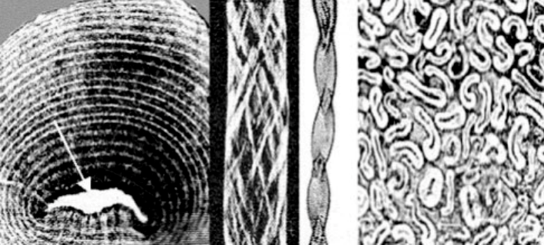

(a) (b) (c) (d)

Fig. 2.1. Cotton fiber morphology

1. 4 parts: –Cuticle; primary wall; secondary wall of concentric cellulosic layers; lumen (arrows)
2. Fibrillar structure
3. Collapsed and twisted longitudinal appearance
4. Fibers of deifferent degrees of maturity

**2.1.2. Physical properties of cotton fibre**

Currently, cottons are graded by HVI measurements on the following parameters:

* Fiber length
* Length uniformity
* Strength
* Micronaire
* Color
* Preparation
* Leaf and Extraneous matter

**Fiber length**

There are two well known methods of assessing fiber length: the staple diagram and the fibrograph (or fibrogram). Appendix 1B gives a brief description each. The fiber length is determined from the fibrograph and is the average length of the longer half of the fiber span length distribution (i.e., the upper half mean length, or UHM length)(5)

**Length uniformity**

The length uniformity index is important to yarn production efficiency as well as yarn strength and evenness. Length uniformity is the ratio of the mean length and the UHM length of the fibrograph and is expressed as a percentage. Because there are variations in length among cotton fibers, the length uniformity will always be less than 100. [5]

Table 2.1. Grading according to the length uniformity index [5]

|  |  |
| --- | --- |
| **Degree of uniformity** | **HVI Length Uniformity Index (%)** |
| Very high | More than 85 |
| High | 83-85 |
| Intermediate | 82-80 |
| Low | 77-79 |
| Very low | Less than 77 |

**Fiber Strength**

Strength measurements are made on the same beards of cotton that are used for measuring fiber length. The beard is clamped in two sets of jaws, 12.5 mm (1/8 in.) apart, and the amount of force required to break the fibers is determined. Strength measurements are reported in terms of grams per tex (g/tex). Therefore, the reported strength is the force in grams required to break a bundle of fibers one tex in count. There is a high correlation between fiber strength and yarn strength. Also, cottons of high fiber strengths are less likely to get broken during the manufacturing processes. [5]

Table 2.2. Grading according to the fiber strength [5]

|  |  |
| --- | --- |
| **Degree of strength** | **HVI strength (g/tex)** |
| Very Strong | Above 30 |
| Strong | 29-30 |
| Average | 26-28 |
| Intermediate | 24-25 |
| Weak | Less than 24 |

**Micronaire**

This is a measure of fiber fineness and maturity. The miconaire of a cotton is determined by measuring the resistance to airflow of a sample of fibers of a specified mass compressed to a fixed volume.7 Low micronaire values indicate fine and/or immature fibers; high values indicate coarse and/or mature fibers. The table below can be used as a guide in interpreting micronaire measurements. Fiber fineness affects processing performance and the quality of the end product in several ways. In the opening, cleaning, and carding processes, low-micronaire, or fine-fiber, cottons require slower processing speeds to prevent damage to the fibers. Yarns made from finer fiber result in more fibers per cross section, which in turn produces stronger yarns, although immature fibers have a negative effect. Dye absorbency and retention vary with the maturity of the fibers. The greater the maturity, the better the absorbency and retention. [5]

Table 2.3. Grading according to the fiber strength [5]

|  |  |
| --- | --- |
| Cotton range | Micronaire reading |
| Premium | 3.7-4.2 |
| Base range | 4.3-4.9 |
| Discount | Above 5 |

**Color**

The color of cotton samples is determined from two parameters: degree of reflectance (Rd) and yellowness (+b). Degree of reflectance indicates the brightness or dullness (degree of greyness) of the sample, and +b the pigmentation level in the fibers. There are five recognized groups of color: white, grey, spotted, tinge, and yellow-stained. A three-digit color code is used. The color code is determined by locating the point at which the Rd and +b values intersect on the Nickerson-Hunter cotton colorimeter diagram for cotton variety.[5]

**Preparation**

Preparation is a term used by classers as an indication of fiber process ability in terms of how easily the cotton was ginned, i.e., smoothness or roughness. Various methods of harvesting, handling, and ginning cotton produce differences in roughness or smoothness of preparation[5]

**Leaf and Extraneous Matter (Trash)**

Trash is a measure of the amount of nonlint material in the cotton, such as leaf and bark from the cotton plant. From a yarn production viewpoint, leaf content and extraneous matter are waste, and there is a cost factor associated with their removal. Also, small particles cannot always be removed, and these particles may detract from the quality of the yarn and the finished fabric.

There are seven leaf grades, designated “1” to “7.” Extraneous matter is any substance in the cotton mass other than fiber or leaf. [5]

Table 2.4. Grading according to leaf and Extraneous Matter (Trash) [5]

|  |  |
| --- | --- |
| **Trash measurement (% area)** | **Classer’s leaf grade** |
| 0.12 | 1 |
| 0.20 | 2 |
| 0.33 | 3 |
| 0.53 | 4 |
| 0.68 | 5 |
| 0.92 | 6 |
| 1.21 | 7 |

# 2.2. A short overview of ring spinning

The ring spinning machine was invented by an American named Thorp in 1828, and Jenk – another American – added the traveler rotating around the ring in 1830. In the intervening period of more than 170 years the ring spinning machine has undergone considerable modification in detail, but the basic concept has remained the same. For many years any noteworthy further development hardly seemed possible, yet a significant process of evolution took place during this time. The productivity of the ring spinning machine has increased by 40 % since the late nineteen-seventies.[6]

This has been achieved by:

* using smaller rings and cop formats;
* introducing piecing in the winding department;
* substantial improvements in rings and travelers

Ring spinning has a very considerable influence on the productivity of the whole process and the quality of the yarn. Ring spinning is still the quality standard benchmark for any new spinning processes. The importance of this universal process is confirmed by the 200 million spindles installed worldwide and by their 80 % share of yarn production in the short staple segment. Impressive advances in performance that have been achieved in recent years as well as striking improvements in yarn quality made possible by the compacting technology, will ensure its dominant market position in the years to come. A fundamental and detailed understanding of the operations involved in the creation of yarn is of crucial importance for all specialists in the spinning industry and textile engineering, as is the close interdependence of the different functions of the process. If material and equipment are to be exploited to their limits – the precondition for surviving in today‘s very tough competitive environment – these limits have to be known. As in the other volumes in this series, an introduction familiarizes the reader with the subject matter as such. The individual elements and their functions are dealt with in the same way, as well as the different influences they exert on the process and quality [6]

# 2.3 Modern winding

2.3.1. Introduction

The principal objective of winding is to assemble many meters of yarn into package form suitable for use in subsequent operations such as weaving and knitting. A suitable package is one that can be easily unwound at high speed. Faults like very thick and very thin places in the yarn length should be removed, but the number of joint ends (i.e., piecings) must be kept to a minimum and, when required, a lubricant (wax) should be applied to the yarn surface. The yarn on packages for high-speed weft knitting is usually waxed. The removal of faults from the yarn is known as clearing and, in practice, clearing and waxing are important aspects of winding.

In the winding process, the two commonly wound package types are the parallel-sided cheese and the cone. Two basic actions are required when producing either package type. A bobbin forming the core of the package must be rotated so that the yarn, while under tension, can be wrapped around the bobbin circumference. Simultaneously, the point at which the yarn is wound must be traversed along the bobbin length. Control of the yarn position can therefore be achieved by regulation of the traverse in relation to the package rotation. In this way, concentric yarn layers can be made to build up to form the package. [5]

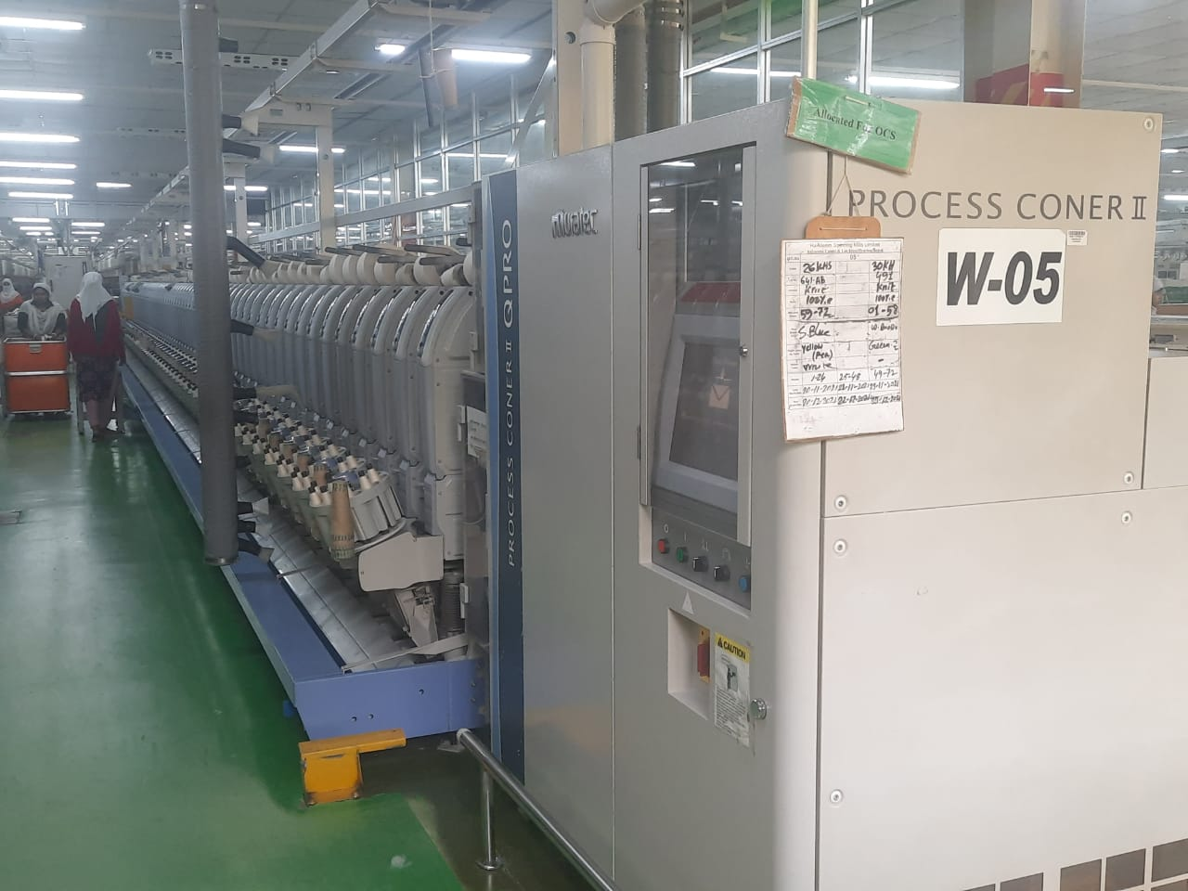

Fig 2.2. Process Coner II winding machine

2.3.2 Objectives of modern winding machine

Winding process has some objectives which are given as below:

* To transfer yarn from spinning bobbin package to a convenient yarn package.
* To improve the quality of yarn.
* To get suitable yarn package.
* To get a quality fabric
* To get good warp yarn
* To empty the spinner’s bobbin so that it can be used again.
* To remove dust and clean the yarn.
* To reduce labor cost
* To improve the efficiency of yarn for next process

### 2.3.3. Requirements of winding

Winding process should be accurate for accelerate the next fabric manufacturing

process. Winding process should fulfill the following requirements:

* Winding process should be easy.
* Characteristics of the yarn should not be changed.
* Winding faults should be minimized
* Yarn package size and shape should be suitable.
* Winding process should be economical.
* Yarn package should be cheap in cost.
* Avoid excess looseness or tightness.
* Exact package hardness.
* In winding, yarn knots should be small in size and amount of knots should

be minimum.

### 2.3.4 Types of winding machine

**(A) According to winding:**

According to winding, winding machine is classified into 2 types. Those are-

1. Precision winding machine.
2. Non precision winding machine.

**(B) According to package:**

Winding machine is classified into 5 types according to package. Those are-

1. Cone winding machine.
2. Cop winding machine.
3. Pirn winding machine.
4. Flanged bobbin winding machine.
5. Cheese winding machine.

**(C) According to drive:**

Winding machine is classified into 2 types according to drive. Those are-

1. Direct motility winding machine.

2. Indirect motility winding machine.

### 2.3.5 Basic structure of winding machine

Basic diagram of winding machine is given below:

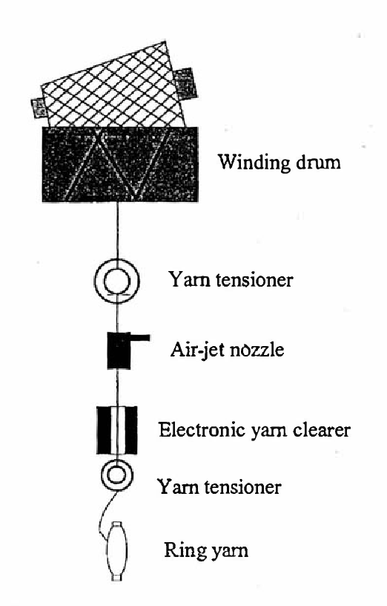

Fig.2.3 Basic diagram of winding machine

### 2.3.6. Units of cone winding machine

The winding machine comprises three units:

1. The creeling and feeding unit,
2. The central unit and
3. The winding unit.

### 2.3.7 Winding speed

The winding speed of the yarn has a direct impact on the production of a spinning factory. With a faster winding speed, a higher production rate can be achieved, but the product's quality is jeopardized. This is why the auto cone's winding speed must be chosen after taking into account a few key factors. These are:

1. Types of yarn
2. Count of yarn
3. Types of splicing device

## 2.4. Developments in cone winding

Though basic objectives of the winding process remain the same, a lot of developments have taken place in the winding machinery. These developments have been directed towards higher output, efficient fault removal from the yarn, better wound package and lesser damage to the yarn. In the subsequent sections the development in cone winding machine is reviewed [7].

The yarn is wound at a very high pace in modern high-speed winding. The yarn used as a supply package is in the shape of a ring bobbin, which is then turned into 1.5 to 2 kg cones or cheese. Generally, high speed winding machine contains the following feature:

1. Creel for holding supply packages
2. Thread guide and balloon breaker
3. Tensioner
4. Clearer or slub catcher
5. Winding drum
6. Bobbin cradle
7. Automatic thread stop motion
8. Full bobbin stop motion
9. Ribbon breaker or anti-ribboning device
10. Driving arrangement

### 2.4.1 Creel supply

A creel or stand is fixed at the bottom of the machine in front and this accommodates ring cops which are used as supply packages. The capacity of the creel is equal to the number of winding drums in the machine. The creel carries holders in the form of pins or rods, upon which are mounted the ring cops. The supply packages are mounted such that unwinding of the yarn from them takes place from the nose portion (overhead unwinding) [8].

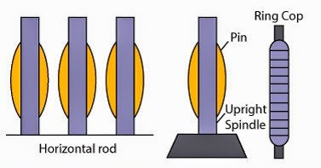

Fig. 2.4 Creel for holding supply package

### 2.4.2. Thread guide and balloon breaker

The yarn after being unwound from the supply package is immediately made to pass through a metallic thread guide above it. The yarn passes to the other devices of the winding machine after passing through the thread guide. Different types of thread guides are used. Some of the well-known ones are the roller guide, winding accelerator etc. [7].

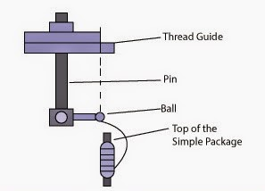

Fig. 2.5 Thread guide and balloon breaker

### 2.4.3 Tensioner

One of the most important aspects of winding is the control of yarn tension. The tension device gives the required amount of tension to the yarn during winding. The tensioner serves a two- fold purpose. Firstly, it enables the weak place in the yarn to be removed and secondly it helps to control the package density of the wound package and thereby ensures uniform density of the wound package. Besides, tensioners also help to remove the impurities adhering to the surface of the yarn [9].

Various types of tensioners are used in high-speed winding machines such as:

1. Washer type tensioner
2. Spinning disc or revolving tensioner
3. Gate or grid bar type tensioner.

## Guides

Yarn guides are necessary to control the yarn path during winding or unwinding. They are generally made of ceramic or steel material and are available in various shapes depending on the unwinding requirements. The yarn may unwind sideways or over end. In the former case, the unwinding may be smooth without any undue vibration. If, however, vibrations may be present or the unwinding is not smooth, yarn guides may be required to control the path of yarn. In the latter case, the yarn does not unwind along a fixed path but rotates. This rotation or circular motion of yarn is termed as ballooning. The position of the yarn guide will influence the shape of the balloon, for a given size of package and yarn speed. It also influences the yarn tension. Hence the position of the yarn guide is an important aspect to be considered [8].

## Clearer or slub catcher

These are also known as snick plates or yarn clearers. They are used to remove the yarn imperfections such as thick places, thin places and slubs. In case of conventional or mechanical type of clearers, thick places and slubs are removed and the tensioners remove the thin places. Thus in winding machines in which the conventional clearers are used the tensioners act partially as yarn clearers in that they remove the thin places. In case of modern clearers which are of the electronic type, the clearer removes all the three types of yarn imperfections and the tensioner only performs the function of ensuring compactness to the wound package [8].

**2.1.3.Winding drum**

This is the most crucial part of the winding machine, on which the wound package is built. The winding drum performs the dual function of winding the yarn on to the package (cone or cheese) and traversing it longitudinally. Thus it builds the package diametrically and longitudinally. In other words, it decides the dimensions of the full cheese or cone. The cylindrical drum consists of grooves cut helically on its circumference from one end to the other and vice versa. These grooves enable the yarn to be traversed. Thus the movement of the drum is described as ‘rotary’ or traverse.

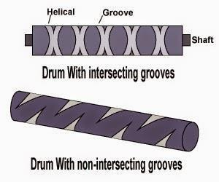

Fig. 2.8. Winding drum

## Cone or cheese holder

This is also known as the bobbin cradle and acts as a support for the winding package which is in the form of a cone or cheese. The package is normally wound on metal or Bakelite tubes or more commonly on paper cones. The bobbin cradle is a device that supports the wound package and enables it to be rotated at high speeds during winding. This device connected to an automatic thread stop motion, which lifts the device off the winding drum in the event of thread breakage during winding. If the winding package is not lifted clear of the drum during a thread breakage, the broken end could possibly get embedded in the layers of the yarn in the package. This would make it difficult and time consuming for location of the broken end on the wound package. In the high speed winding machines, different types of arrangements are available for holding the cheeses or cones [9].

The important types of cone/cheese holders are

* One arm cone holder
* Two arm package cradle
* Radial cheese holder

## Automatic broken thread stop motion

Since the wound packages rotate at high speeds, it is necessary that stop devices be provided to stop winding in the event of thread breakage or exhaustion of supply package during winding. The stop motion should be able to immediately lift the particular cheese or cone out of contact with the winding drum in such an event. If the cone or cheese is allowed to run on the winding drum, after thread breakage, the end of the broken thread will be embedded and lost in the layers of yarn on the packages. This would render it difficult for the winder to locate the broken end on the cone.

Full package stop motion

As soon as the wound package has reached the preset or predetermined size, the full package stop motion automatically lifts it out of contact with the winding drum or shaft. This is necessary to obtain equal length of yarn on all the cones or cheeses of the particular set or lot as otherwise it causes problems in warping due to different cones in the warping creel exhausting at different times. The warping machine production and efficiency is adversely affected in such a case. Further, in the case of cheeses which are to be dyed in that form, it is necessary to have all the cheeses of particular size according to the spacing of the spindle which holds them in the cheese dyeing machine.

Ribbon breakers

These are also variously known as pattern breakers or anti-ribbon devices. The patterning is a defect that occurs during winding. Ribbons or patterns are formed when each additional layer of yarn is laid exactly in the same position of the previous layer on cone or cheese during winding. The pattern or ribbon so formed, is however, neither visible to the naked eye nor has any adverse effect on the subsequent process for which the cone or cheese is intended. Also it will not be possible to obtain uniform dyeing or bleaching, since the flow and penetration of dye or bleach liquor will be adversely affected by the yarn where the ribbon is formed. It is therefore essential that the formation of ribbon has to be eliminated [8].

There are three methods for doing this

Method based on changing the speed of winding drum

Method based on lifting intermittently the winding package from the winding drum

Method based on using not-intersecting grooves

Driving arrangements

The winding machines are usually driven from individual motors, which transmit motion to the winding shaft through either reduction gears or three stage pulleys. Each side of the machine may have a separate motor, so that one may run independently of the other. Push button control may be provided at one of the ends of the machine to start or stop. The individual motors are usually three phase motors provided with automatic arrangement for breaking the circuit at regular intervals in order to alter the periodicity. A three stage pulley enables speed variations to be made according to the type of material worked without the necessity of altering any gearing .

Other developments

BQC (Balloon quality control) auto reset device

High speed auto doffing

Winding head control and drum drive

A flexible intelligent cycle & energy saving

Electronic yarn clearer

The introduction of electronic yarn clearer in mid of 19th century was revolutionary not only for spinning mills but for it’s down & upstream too. Now a day it is essential accessories of new generation autoconer. In last two decay tremendous research & innovation work done in the field of electronic yarn clearer’s that helps spinners for increasing the yarn quality & productivity as well as reducing rejection & waste generation with increase in working efficiency in spinning & textile clothing industries. Many special features have been added into these clearers for getting adequate yarn quality and for special quality purposes. However, it is still a hectic job for textile technicians to set & utilize all these features at a time for improving yarn defects or improving yarn quality in order to full customer satisfaction by achieving target productivity level [8].

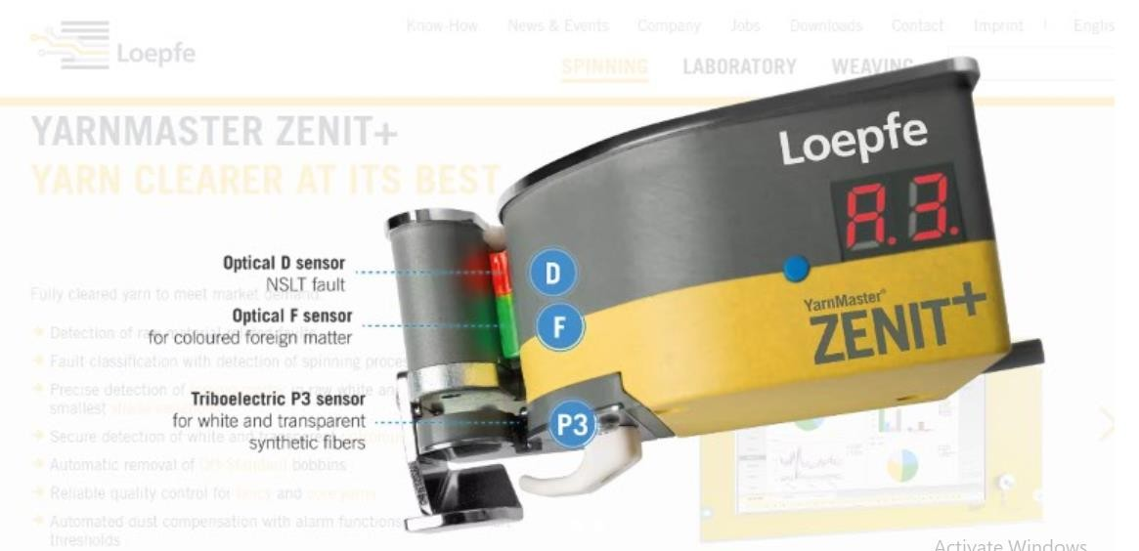

Fig. 2.9. Yarn master ZENITH+ electronic yarn clearer Electronic yarn clearers are mainly works on two different principles as below: -

The optical measuring principle

The capacitive measuring principle

The optical measuring principle for yarn clearer

The optical measuring sensing head’s works on “Infrared light transmission” principal. The infrared light (1) is scattered by a diffuser (2) in the light field and reaches to the photocell (3). The photocell emits a tension, which is proportional to the amount of light. If a yarn (4) is brought in the light field, parts of the light will be absorbed by the yarn. The amount of light, which hits the photocell, is smaller. From this change, an electrical signal, the yarn signal (5) is derived. With the optical measuring principal, the yarn signal corresponds to the diameter of the usually round yarn, which is located inside the measuring field. Changes of the yarn diameter cause a proportional change of the yarn signal [10].

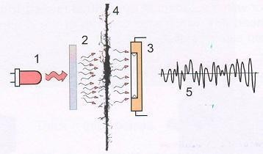

Fig. 2.10. Optical principles for yarn clearer

The capacitive measuring principle for yarn clearer

In capacitive measuring principle two parallel metal plates (i.e. electrodes) (1) works as the sensor and these electrodes build a measuring electrical field in between the space

(2) of two electrode plates when putting on an electrical alternative voltage (3). If a yarn (4) is brought into this field, the capacity of the measuring condenser is changed. From this change, an electrical signal, the yarn signal (5) is derived. The change in the capacitance depends, besides of the mass of the yarn and of the dielectric constant of the fiber [10].

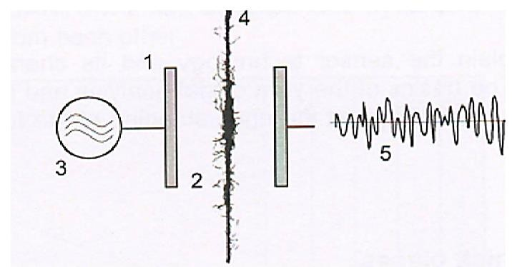

Fig. 2.11. Capacitive measuring principle

Colored foreign matter measurement

Color foreign matters are measures against the contrast between the yarn body and foreign matter. The intensity of the contrast does not only depend on the color of the foreign matters, but also on its base yarn surface structure. The wavelength of the light which is used in the sensor also plays an important role. The signal which is generated by the foreign matter is defined as the intensity of the foreign matter. The intensity of foreign matter depends on change of the light reflection [8].

Synthetic foreign matter (P) detection

The detection of synthetic foreign matter as polypropylene, polyamide (nylon) etc. is generally based on an electrical phenomenon where certain materials become electrically charged after coming into contact with another different material. The polarity and strength of the charges produced differ according to material and surface smoothness. That means, the further materials lie off each other in the series, the more definitely they can be detected.

Yarn conditioning

Moisture in atmosphere has a great impact on the physical and mechanical properties of textile fibers and yarns. Relative humidity and temperature decide the amount of moisture in the atmosphere. High-speed spinning machines generate high friction and provide additional heat to the yarn, as a result moisture content of yarn is decreased due to evaporation of its moisture content by additional heat. Increasing the speeds in spinning result in decreased yarn quality for other processes because dry yarn has the worse properties and if it is sold then result in monetary loss [11]. For example, MR% of cotton bale is more or less 10%, but it becomes 5% after winding. Yarns sold with lower moisture content than the standard value will result in monetary loss. If yarns are supplied to market in the form of reduced MR%, spinning mill has to incur great financial loss due to the less weight. On the other hand, a high degree of moisture improves the physical properties of yarn. Therefore, the aim of conditioning is to provide an economical device for supplying the necessary moisture in a short time to take back the yarn to the standard MR% of cotton i.e. 8.5%, in order to achieve a lasting improvement in quality. Conditioning is to provide an economical device for supplying the necessary moisture to yarn to achieve its natural moisture content. Yarn conditioning is a process in which yarn is conditioned for better performance (such as strength, serviceability, luster, handle etc.) by increasing relative humidity in its surroundings or by providing moisture in steam or any suitable form [7]. Single yarns are inherently unstable because the fibers within them are under torsional stress and want to return to their unstressed state by unwinding. The yarn is said to be twist lively. Indeed, too much twist can cause the yarn to snarl or twist around itself. Yarn conditioning can reduce or even eliminate this tendency of undesirable torque. At the winding, twisting, warping, sizing, weaving and knitting processes, an increased tendency to torque can cause difficulties in processing of the yarn. Hence they need proper twist setting. Twist setting is necessary to ensure a balanced yarn by avoiding snarling in further processing. Pure cotton yarns can be satisfactorily set simply by conditioning whereas hydrophobic fibers like polyester have to be yarn conditioned because of their thermoplastic nature. Twist setting can be done either in ring bobbin or cones, but mostly done in cone form.

Principle of yarn conditioning

Thermal conditioning uses low-temperature saturated steam in vacuum*. With the vacuum principle and indirect steam, the yarn is treated very gently in an absolutely saturated steam atmosphere. The vacuum first removes the air pockets from the yarn package to accelerate penetration of steam into all the layers of yarns on cone and ensure even conditioning effect throughout the package. Vacuum also removes the atmospheric oxygen in order to prevent oxidative degradation. The conditioning process makes use of the physical properties of saturated steam or wet steam (100% moisture in gas-state). The yarn is uniformly moistened by the gas. The great advantage of this process is that the moisture in the form of gas is very finely distributed throughout the yarn package and does not cling to the yarn in the form of drops. This is achieved in any cross-wound bobbins.

**Capacity**: It is a closed vessel, named vacuum yarn conditioned or autoclave, containing some trolleys (5 or 6). Each trolley holds the packages in its pegs. One trolley may contain 50-60 or more cones. Saturated steam is applied under particular temperature and pressure for certain periods.

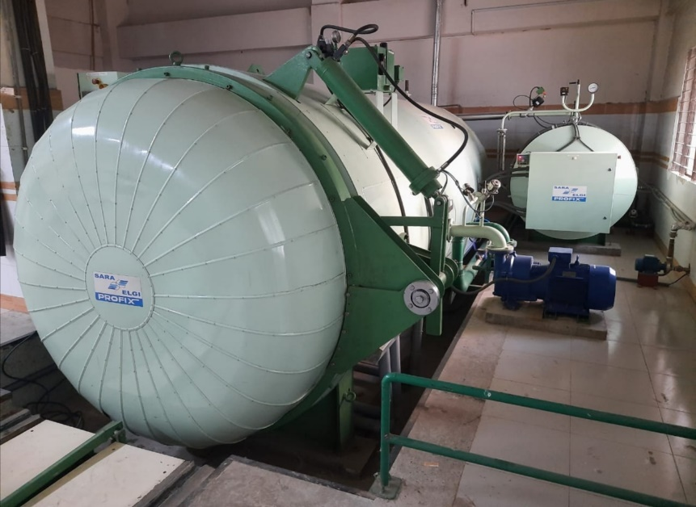

2.12. Yarn conditioning machine

Process parameters of yarn conditioning are given below:

Table 2.8. Process parameters of yarn conditioning

|  |  |  |  |
| --- | --- | --- | --- |
| **Cycle** | **Temp.** | **Time (Winter)** | **Time (Summer)** |
| **Vacuum** | Room | 6 min | 6 min |
| **Steam** | 50 ºC | 20 min | 15 min |
| **Vacuum** | Previous | 2 min | 2 min |
| **Steam** | 55 ºC | 10 min | 8 min |
| **Dwell Time** | Previous | 10 min | 8 min |

Effect of conditioning on cotton yarn properties

Yarn physical and mechanical properties are directly affected by its moisture content and due to heat of high production machines, it evaporates and deteriorate the yarn properties. Moreover, now a high production level is achieved in weaving and knitting machines due to which yarn quality required to run on these machines should be very good. To satisfy these demands without changing the raw material, it is possible to use inherent properties of cotton fibers in short staple spinning [11]. Cotton fiber is hygroscopic material and has the ability to absorb water in the form of steam. Hygroscopic property of cotton Fibers is directly related with relative humidity. The higher the humidity and more will be the moisture absorption. An increase in relative humidity of atmosphere increase the moisture content of cotton fiber [7].

The fiber strength and elasticity increase with the increase in moisture content. If the water content of the cotton fiber is increased, the fiber swells and result in an increased fiber to fiber friction in the twisted yarn structure due to which strength and elasticity of yarn are increased. So, to increase moisture conditioning processes are used to increase humidity in yarn surroundings to increase its moisture content [11].

After conditioning, while a majority of the quality factors get well, there is a clear increase in imperfection values provided by capacitance type evenness testers [10]. The increment in yarn imperfections normally occurs because of mechanical processing mainly rubbing of yarn on any peripheral surface. Throughout conditioning, this does not acquire. Therefore, a study has been undertaken to recognize the same and to have a solution to the problem of increased imperfections.

In addition to subsequent processes problems, monetary loss for a spinner is increased because the evaporation of moisture results in weight loss of final yarn package [10]. To overcome all these problems, the best way is to maintain the natural moisture content or to provide enough humidity at the end for moisture regain of fibers. The first condition is impossible to achieve but the second way is applicable and is used. So conditioning is must for a spinner to optimize monetary losses and for a weaver and knitter for smooth (low breakage) running of operations.

Benefits of yarn conditioning

For knitting: The treatment temperature for knitting yarn is held below the melting point of the wax. Temperatures for unwaxed yarn are coordinated to the compatibility of each individual type of yarn.

Up to 20% greater efficiency due to a reduction in the unwinding tension

Fewer needle breaks

Uniform moisture content and friction values

Regular stitch formation

No change in size of finished articles

No extra dampening required

Free from electrostatic

Less fly hence less problems. It helps if the yarn is running on a closer gauge machines

For weaving:

Up to 15% fewer yarn breaks due to greater elongation

Less fly, resulting in a better weaving quality

Increased strength

Increased take-up of size, enhanced level of efficiency in the weaving plant

Softer fabrics

For twisting: Conditioning and fixing of the twist at the same time in a single process. For dyeing:

No streaks

Better dye affinity

Yarn quality parameters

Yarn irregularity

Yarn irregularity is a measure of the level of variation in yarn linear density or mass per unit length of yarn. In other words, it refers to the variation in yarn count along its length. A common method of expressing the irregularity of yarn is to use the statistical term CV or co-efficient of variation and another one is Unevenness Um% [11].

#### Unevenness (Um%)

It is the percentage mass deviation of unit length of material and is caused by uneven fiber distribution along the length of the strand [11].

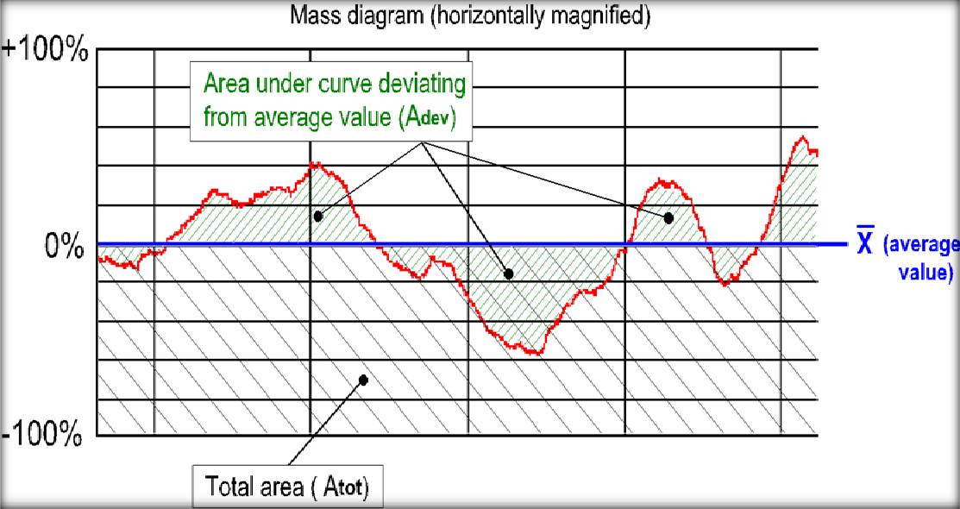

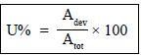Fig. 2.13. Mass per unit length variations Then Um% is given by:

In graphical form, Um% is the area of the mass signal of the tested material which deviates from the average value, expressed as a percentage of the total area (total area

= full mass of sample).

In mathematical form Um% = Mean Deviation / Mean ×100

= 1 ∑|xi−x̅| × 100

x̅ 𝑛

Here, 𝑥𝑖= Instantaneous value of the mass

𝑥̅ = Mean value

Coefficient of variations (CVm%)

The coefficient of mass variation CVm% is the ratio of the standard deviation of mass variation divided by the average mass variation. The higher the CV value is the more irregular the yarn.

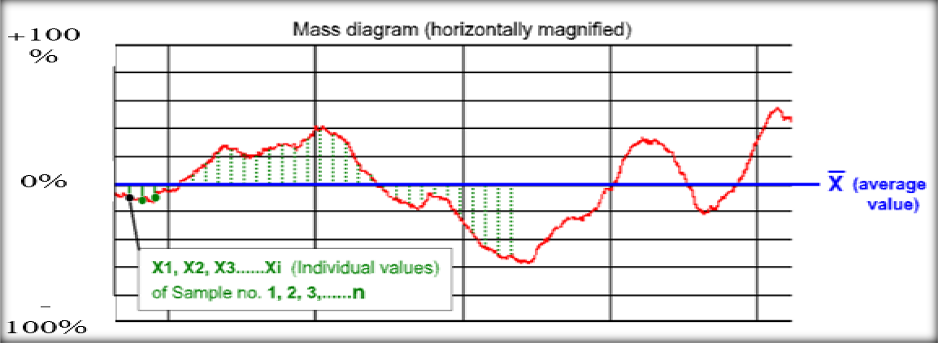

Fig. 2.14. Graphical representation of coefficient of variations

A measure of the size of the mass variations is the standard deviations, which is expressed as

CVm = 𝜎 ×100%

𝑥̅

[Where, σ = standard deviation, X̅ = arithmetic mean]

## Imperfection index (IPI)

The imperfection index (IPI) of spun yarns can be defined as the sum of yarn thin places, thick places and neps per 1000 meters of yarn length. In the USTER evenness tester, thin and thick places refer to imperfections that are within the measuring sensitivity range (±50% with respect to the mean value of yarn cross-sectional size), while neps are classified as the yarn imperfections which may exceed the 200% limit [11].

Table 2.9. IPI threshold for ring spun yarn [10]

|  |  |
| --- | --- |
| **Imperfections** | **Sensitivity Thresholds** |
| Thin places | -50% |
| Thick places | +50% |
| Neps | +200% |

**Thin place (-50%):** Thin places (-50%) means in this area the yarn diameter is 50% of the average diameter of yarn, which is not being enough fibers in a yarn cross-section to support the yarn structure (a thin place).

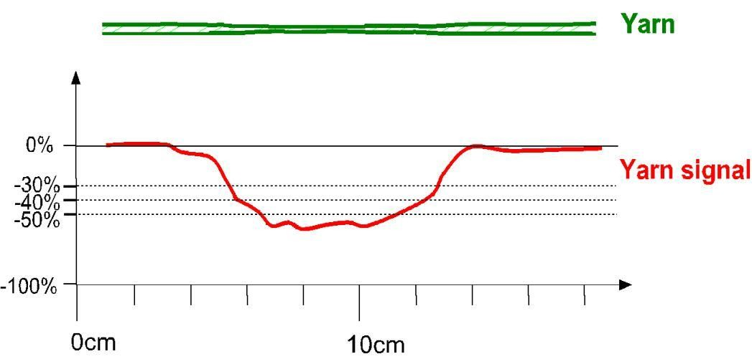

Fig. 2.15. A thin place in yarn and corresponding yarn signals

**Thick Place (+50%):** Thick place (+50%) means here the diameter of the yarn is 150% to the average diameter of yarn.

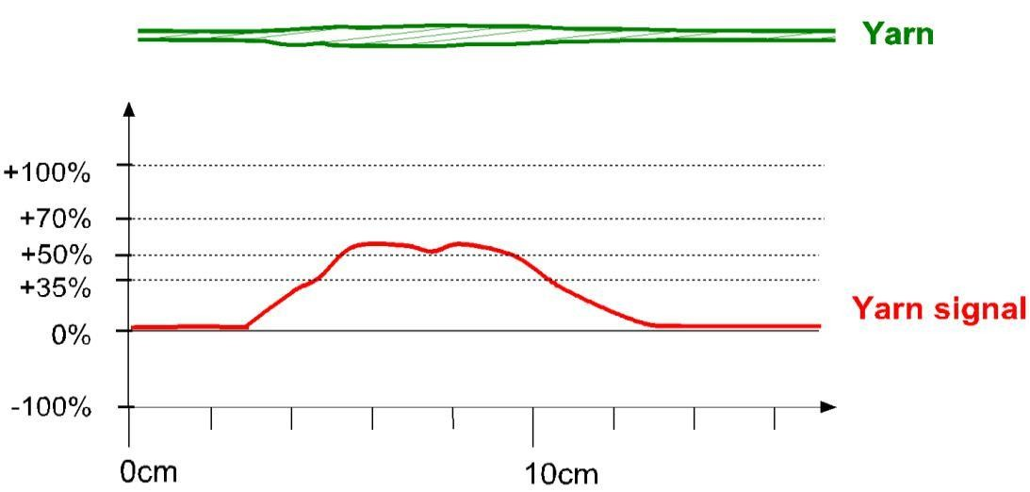

Fig. 2.16. A thick place in yarn and corresponding yarn signals

**Neps (+200%):** Neps (+200%) indicates the cross-section at the nep is 300% of the yarn mean value or more [12].

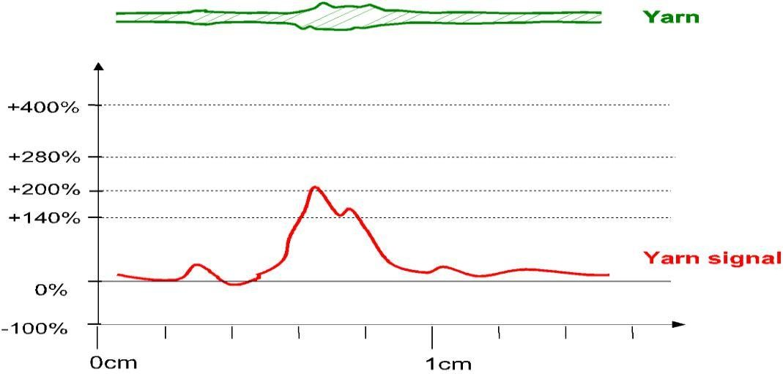

Fig. 2.17. A Neps in yarn and corresponding yarn signals

Hairiness index (H)

Yarn hairiness is one of the essential parameters which influences the performance of yarn in the subsequent processes. Yarn hairiness has a considerable effect on the appearance and handle of Fabric, as well as on the formation of pilling.

Hairiness can be defined as the total protruding fiber length that projects from the yarn body of 1cm. Provided that H is the relation between (of hairs and yarns) it is a nun dimensional quality [10].

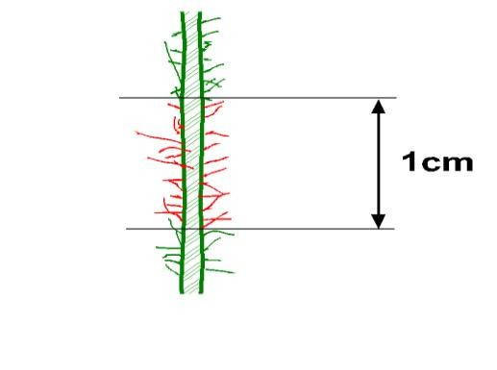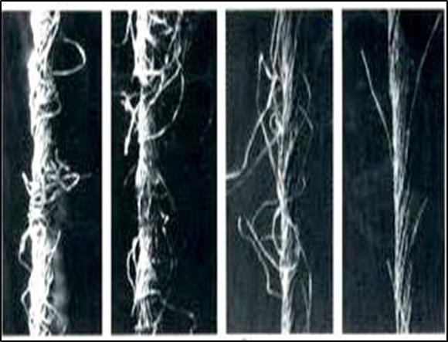

Fig. 2.18. Hairiness on single yarn body

Count strength product (CSP)

Count strength product was determined by multiplying the actual count value with the respective breaking load of yarn lea of 120 yards according to British Standards

Yarn fault classification

To understand the function of an electronic yarn clearers, it is most important to know that how different defects are being classified under it. Each electronic yarn clearers used their own terminology for different yarn defects.

For easy understanding of new generation electronic yarn clearers broadly we can classify yarn defects as below:

**Yarn Imperfections:** Unevenness of yarn is generally considering in this class. It is further classified into following four classes that is commonly known as NSLT classes:

**Neps:** Thick places less than 1 cm. length and more than 2.5 times in diameter against base yarn are being consider as Neps.

**Short thick:** Thick places more than 1 cm. and less than 8 cm. with a considerable thickness i.e. above 1.5 times the base yarn diameter.

**Long thick:** Thick places more than 8 cm. length and thickness above 1.2 times with base dia.

**Thin places:** Thin places more than 8 cm. and diameter less than 0.8 times of base yarn.

**Count Variation:** Deviation of count from its mean value which is not allowed in finished product or it may reflect in finished fabric. This may be further bifurcated into two classes according to its length & diameter difference i.e.:

Short term count variation

Long term count variation

**Periodic defects:** Thick & thin places which always occur with the same distance from each other, created in spinning process due to some mechanical disturbance.

**Splice defects**: Poor yarn joint quality is also creating problem in next process, either it is weak splice or bad shape splicing.

**Foreign Matters**: Foreign matter that is different either in color or in properties with base yarn. Generally, in textile language it is known as “Contamination”. This is again bifurcated into two more classes i.e.

**Contrast Foreign Matter:** Foreign matter that is different in color with base yarn such as dark color fibers in grey yarn, white or other color fibers in dark shade yarn etc.

**Synthetic Foreign Matter:** Foreign matter that may be of same or near color of base yarn but different in properties such as polypropylene, nylon, synthetic fibers in cotton yarn etc.

**Winding defects:** Winding defects such as drum lapping, bunches, system malfunctioning etc. consider in this class.

**Bad Quality / Off Standard cops:** Most of new generation electronic yarn clearers are competent to identify the spinning bad quality cops through different – different channels. Neppy yarn, high hairiness, excessive imperfection & foreign matter in a single cop may be classified in this class.

# 

# 

# 

# **Chapter 03: Materials & Methods**

# Fibre used:

The properties of the raw material determine the processing parameters of the spinning machinery and the quality of final yarn. For our project experiment, raw cotton of Burkina faso origin was used. Properties of raw cotton as follows –

## Table 3. 1: Properties of raw cotton (Burkina faso)

|  |  |
| --- | --- |
| **Properties** | **Value** |
| UHML (mm) | 28.24 |
| Staple length (mm) | 30 |
| Mic | 4.53 |
| Strength (g/tex) | 29.00 |
| Color Grade | 31-3 |
| UI (%) | 80.5 |
| SCI | 123 |
| SFI | 10.7 |
| Elongation (%) | 6.7 |
| Maturity | 0.87 |
| Rd (%) | 76.3 |
| +b | 9.4 |

# Process flow chart of sample preparation:

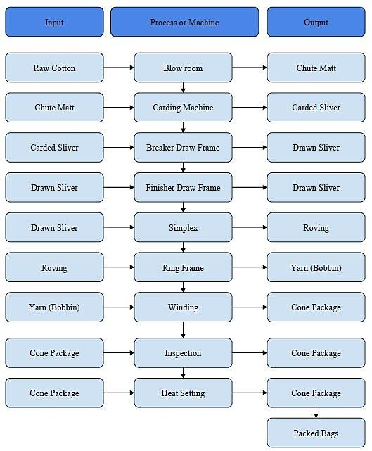

# Working Procedure:

The working procedure of the project is described below:

* + 1. Barkina cotton was tested by USTER HVI and bale management was done according to the fiber properties of MIC and +b.
    2. The production process from blow room to finisher draw frame was observed carefully and settings were noted down.
    3. Then the simplex machine number 1 was selected for roving preparation. 50 flyers were occupied for 50 roving bobbins preparation from the finisher drawn sliver. The length of roving in each bobbin was 700 meters.
    4. The ring frame number 12 was nominated for the study. The spindle number of 1 to 50 was selected to manufacture 20 Ne,30 Ne carded yarn.
    5. Five random sample from The produced ring cops were taken to quality control laboratory for measuring the yarn evenness, imperfection by Uster Evenness Tester-5, CSP by the help of wrap reel and lea strength tester.
    6. The winding machine no. 6 was selected for cone preparation. 4 cone package were built at four different winding speed (1300, 1400, 1500, 1600 m/min). The fault found during building of cone were noted and samples were taken to QC lab for testing.
    7. After all the testing, the samples were rewind again at a common speed of 1000 m/min.
    8. The rewind samples were taken for yarn conditioning and after yarn conditioning, they were taken again to QC lab for measuring evenness and CSP.

# : Machine Descriptions:

## : UNIfloc:

It is a machine that opens fibers from the raw cotton bales in tuft forms. Its primary function is to open the bale by the use of air suction and opening rollers. These turn the materials into small tufts. The UNIfloc traverses along the laydown to ensure that all the bales are fed into it in an even manner to ensure homogeneity.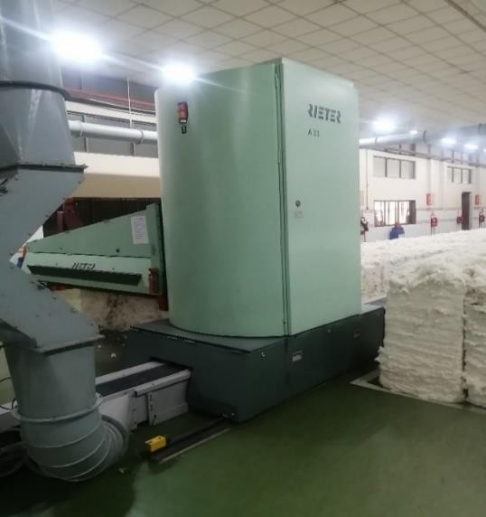

## Figure 3. 1: UNIfloc Machine

**Machine Specifications:**

|  |  |
| --- | --- |
| Manufacturing Company | Rieter |
| Model | A 11 |
| Manufacturing Year | 2015 |
| Country of Origin | Switzerland |
| Production rate | 1400 kg/hr. |
| Channel Length | 30 m |
| Opening roller | Double tooth brush part |
| Number of Machines | 2 |

## : UNIclean:

It is a machine that cleans fibers from the tuft forms. The primary function of UNIclean is to perform coarse cleaning of fibers in tuft form. This is done with the help of an opening roller that cleans the fibers. Mostly the larger trash particles are cleaned.

## Machine Specifications:

|  |  |
| --- | --- |
| Manufacturing Company | Rieter |
| Model | B 12 |
| Manufacturing Year | 2014 |
| Country of Origin | Switzerland |
| Production Capacity | 1400 kg/hr. |
| Cleaning Intensity | 0.3 |
| Pin Roller | 680 rpm |
| Relative Wastage Rate | 6 |
| Number of Machines | 2 |

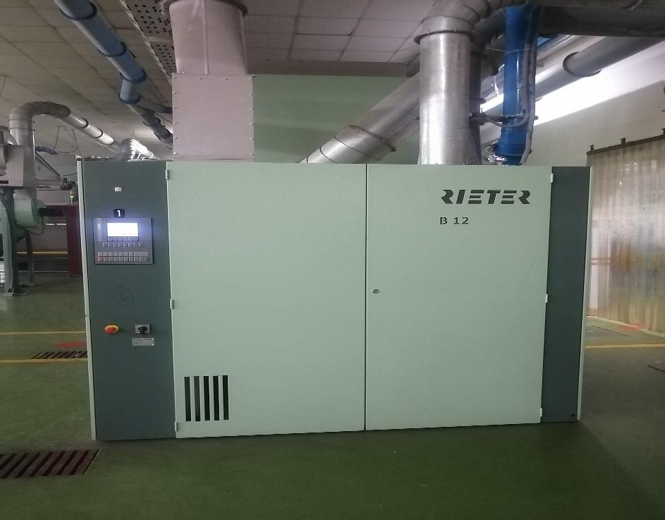

**Figure 3. 2: UNIclean**

## 3.1.3: UNImix:

It is a machine that mixes the fibers into a homogeneous mixture. This machine has 8 chambers. These are filled periodically. The final product is the mixture from the eight chambers which ensures that the fibers are homogeneous even though they are taken from different bales with different properties.

## Machine Specifications:

|  |  |
| --- | --- |
| Manufacturing Company | Rieter |
| Model | B 72 |
| Manufacturing Year | 2015 |
| Country of Origin | Switzerland |
| Production Capacity | 700 kg/hr. |
| Cleaning Intensity | 0.2 |
| Relative Wastage Rate | 1 |
| Degree of Opening | 0.6 |
| Conveyer Belt | Automatic |
| Spiked Feed Lattice | 178 rpm |
| Feed Roller | 7.4 rpm |
| No of chamber | 8 |
| No. of Machine | 1 |

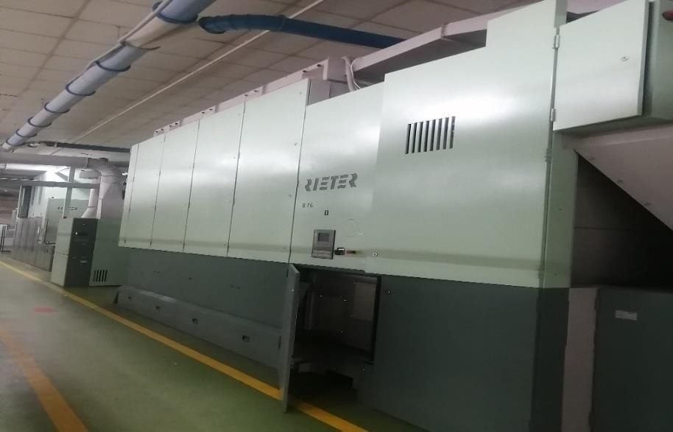

**Figure 3. 3: UNImix**

## : UNIstore:

It is a machine which removes fine particles, immature fibers and short fibers from the cotton. The UNIstore is a fine cleaning machine. It is operated by the use of a dust extractor. The material enters the storage module first, then the machine opens the fibers and the dust extractor is used to clean it.

## Machine Specifications:

|  |  |
| --- | --- |
| Manufacturing Company | Rieter |
| Model | A79 |
| Manufacturing Year | 2015 |
| Country of Origin | Switzerland |
| Production capacity | 1300 kg/hr. |
| Cleaning Intensity | 0.1 |
| Relative waste rate | 3 |
| Feed roller | 5.3 rpm |
| Opening Roller | 615 rpm |
| No. of Machine | 2 |

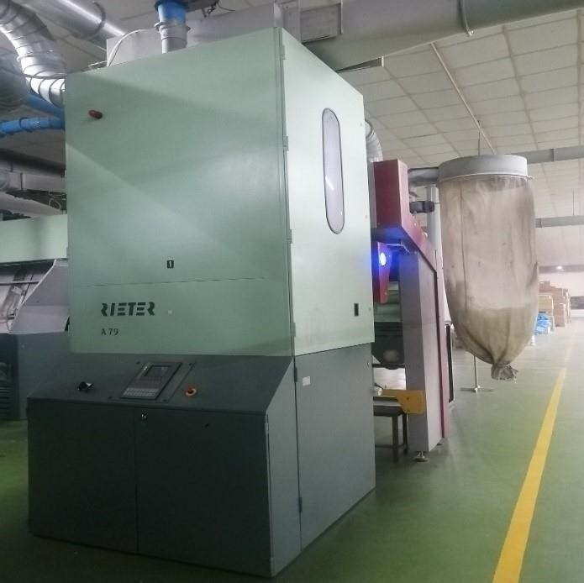 **Figure 3. 4: UNIstore**

## : Jossi Vision Shield:

It is a machine which removes colored contamination from the cotton. This machine is used to detect the colored contamination in the fibers with the help of UV cameras and optical sensors. This removes contamination which can affect the later stages. This is especially used to detect white Polypropylene.

## Machine Specifications:

|  |  |
| --- | --- |
| Manufacturing Company | USTER |
| Model | Jossi vision shield |
| Year of manufacturing | 2015 |
| Country of Origin | Switzerland |
| Material Used | Cotton |
| No. of machine | 2 |

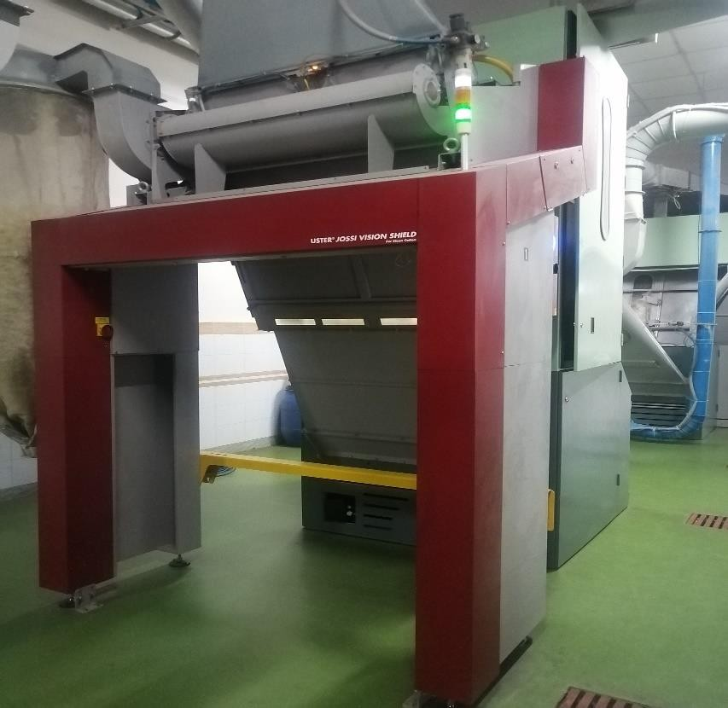

**Figure 3. 5: Jossi Vision Shield**

## : Jossi Magic Eye:

It is a machine which helps to remove white and transparent contamination from the cotton**.** This machine is used to detect the white and transparent contamination in the fibers with the help of UV cameras and optical sensors. This removes contamination which can affect the later stages.

## Machine Specifications:

|  |  |
| --- | --- |
| Manufacturing Company | USTER |
| Model | Magic Eye |
| Year of manufacturing | 2018 |
| Country of Origin | Switzerland |
| Material Used | Cotton |
| No. of machine | 2 |

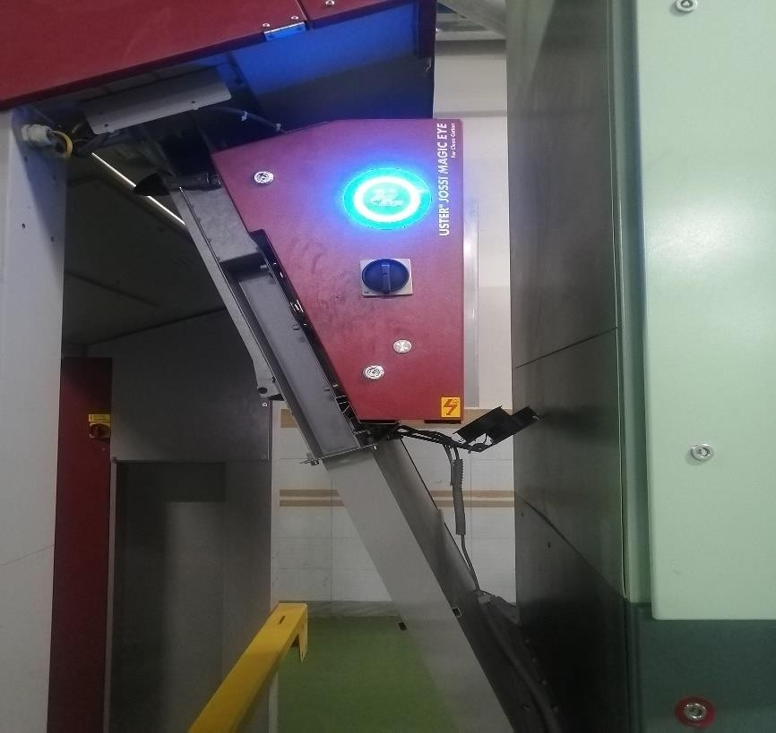

**Figure 3. 6: Jossi Magic Eye**

## : Carding Machine:

It reduces the entangles mass of fibers into a filmy web working. It makes carded sliver from the chute matt. To demonstrate its significance, it is called the heart of spinning and proper carding is half of spinning to demonstrate the immense significance of carding for the final result of the spinning operation.

## The Objectives of Carding are:

* + - * To remove short and immature fibers.
      * To disentangle neps from the cotton fibers.
      * To individualize and slightly straighten including parallelization.
      * To make a uniform sliver.
      * To clean the heavy particles by stripping and carding action.

## Machine Specifications:

|  |  |
| --- | --- |
| Manufacturing Company | Rieter |
| Model | C 70 |
| Manufacturing Year | 2015 |
| Country of origin | Switzerland |
| No. of machine | 22 |

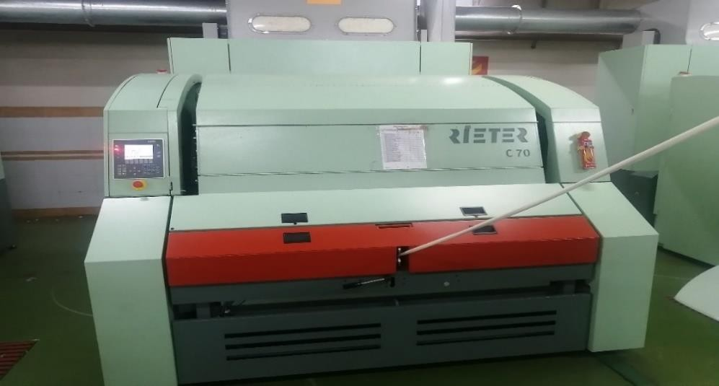

**Figure 3. 7: Carding Machine**

**Technical parameters of Carding machine are given below: Table 3. 2: Technical parameters of the carding machine**

|  |  |
| --- | --- |
| **Technical Parameters** | **Values** |
| Delivery roller diameter | 80 mm |
| Feed roller diameter | 172 mm |
| Taker in diameter | 253 mm |
| Cylinder diameter | 814 mm |
| Doffer diameter | 680 mm |
| Delivery speed | 226 m/min |
| Licker in speed | 1200 rpm |
| Cylinder speed | 850 rpm |
| Licker in PPSI | 120 |
| Licker in Index | 48 |
| Cylinder PPSI | 965 |
| Doffer PPSI | 340 |
| Flat PPSI | 550 |
| Top Flat speed | 220 mm/min  330 mm/min  380 mm/min |
| Number of Flat | 99 (34 were on Action) |
| Flat wire angle | 70 º |
| Cylinder to taker in gauge | 0.30 mm |
| Cylinder to doffer gauge | 0.225 mm |
| Auto leveler | Close loop |
| Sliver weight | 84 grain/yds. |
| Total draft | 115 |

## : Draw Frame:

The carded sliver is fed in the Breaker Draw Frame. It applies draft and doubling. The more no. of doublings gives more removal of irregularity. If the number of doubling increases, the number of drafting also increases. But more draft leads to more unevenness in the drawn sliver. So optimum doubling should be maintained. The main difference of finisher draw frame to breaker draw frame is the auto leveler. The auto leveler can remove a maximum of about ±25% variation.

## The Objectives of the draw frame are:

* + - * To minimize the irregularity by doubling.
      * To do blending or mixing.
      * To produce a uniform sliver.
      * To straighten and parallelize the fibers by drafting and drawing.

## Machine Specifications:

|  |  |  |
| --- | --- | --- |
| Manufacturing  Company | Rieter Breaker Draw  Frame | Rieter Finisher Draw  Frame |
| Model | SB D-45 | RSB D-45 |
| Manufacturing Year | 2015 | 2015 |
| Country of origin | Switzerland | Switzerland |
| Number of Machine | 11 | 11 |

**Figure 3. 8: Breaker Draw Frame Figure 3. 9: Finisher Draw Frame**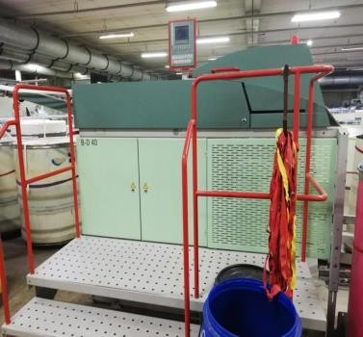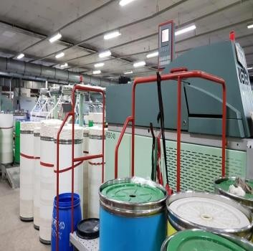

**Table 3. 3: Technical parameters of drawing:**

|  |  |  |
| --- | --- | --- |
| **Technical Data and Setting** | **SB D-15 (Breaker)** | **RSB D-15 (Finisher)** |
| Drafting system | 4 over 3 | 4 over 3 |
| No. of head | 2 | 1 or 2 |
| Roller weighting system | Pneumatic | Pneumatic |
| Cot roller shore hardness | 83 ºA (Carded) | 83 ºA (Carded) |
| 75 ºA (Combed) | 75 ºA (Combed) |
| Bottom roller diameter | Front roller - 40 mm | Front roller - 40 mm |
| Middle roller - 30 mm | Middle roller - 30 mm |
| Back roller - 30 mm | Back roller - 30 mm |
| Top roller diameter | Front roller - 38 mm | Front roller - 38 mm |
| Middle roller - 38 mm | Middle roller - 38 mm |
| Back roller - 38 mm | Back roller - 38 mm |
| Bottom roller gauge | Front zone - 38 mm | Front zone (KH) - 38 mm |
| Back zone - 42 mm | Back zone (KH) - 42 mm |
| Bottom roller gauge |  | Front zone (CH) - 40 mm |
|  | Back zone (CH) - 44 mm |
| Delivery speed | 700 m/min | 550 m/min |
| Sliver hank (Ne) | 0.11 Ne | 0.11 Ne |
| Break draft | 1.4 | 1.15 |
| Total draft | 6.35 | 7.36 |
| Auto leveler | Not present | Present |

## : Simplex:

The finisher draw frame slivers are fed to the simplex. It imparts draft and a small amount of twist to form roving. The sliver is extended and a small amount of twist is inserted. This twist only helps to hold the fiber during winding of roving and unwinding of slivers.

## The functions of the roving frame are:

* + - * To produce roving by drafting.
      * To insert the twist on roving to hold the fibers.
      * To wind the roving on to the bobbin.

## Machine Specifications:

|  |  |
| --- | --- |
| Manufacturing company | Toyota |
| Model | FL-200 |
| Manufacturing Year | 2015 |
| Country of origin | Japan |

**Figure 3. 10: Simplex Machine**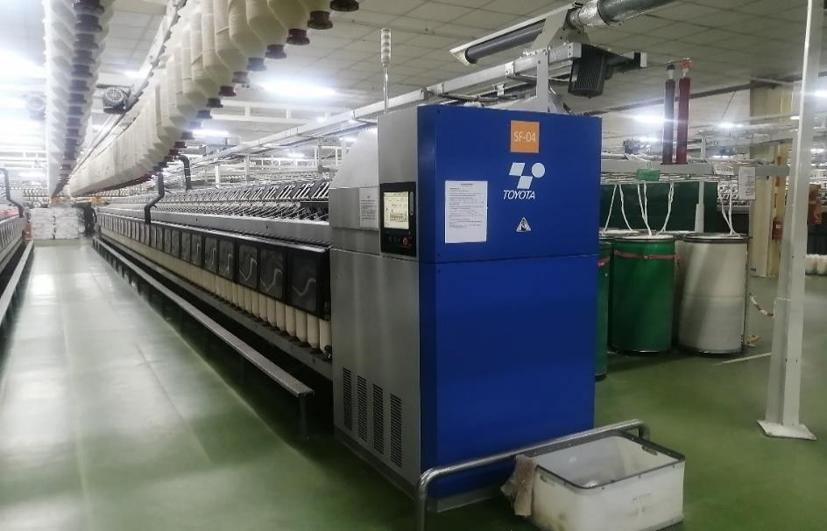

**Table 3. 4: Technical parameters of simplex machine:**

|  |  |
| --- | --- |
| **Technical Parameter** | **Values** |
| Drafting system | 4 over 3 |
| No of machine | 11 |
| No. of spindle | 132 |
| Spindle gauge | 220 mm |
| Roller gauge | Front - Middle: 40  Middle - Back: 51 |
| Flyer gauge | 220 mm |
| Bottom Roller Diameter | Front: 28.5 mm  Middle: 28.5 mm  Back: 28.5 mm |
| Roving hank | 0.75 Ne |
| Roving TPI | 1.21(KH) |
| Break Draft | 1.21 |
| Total draft | 7.19 |
| Auto stop motion | Yes |
| Problem indicating lamp system | Yes |
| Arm pressure | 12-20-15-15 kg |
| Top apron size | 37 X 39.8 X 1 mm |
| Bottom apron size | 38.8 X 39.8 X1.4 mm |
| Condenser size | 15 mm |
| Flyer speed | 1100 rpm |
| Spacer size | Green- 7.5 mm  Ash- 6.5 mm  Black -5.5 mm  White- 4.5 mm |

## : Ring Frame:

Ring frame produces the final product. This is done by imparting a huge amount of twist and a huge amount of draft to the roving. The twist is imparted by the traveler. Thus, true twist is imparted in ring frame.

## The functions of the ring frame are:

* + - * To draft the roving unit and to produce yarn.
      * To impart strength to the fiber by inserting twist.
      * To wind up the twisted strand (Yarn) on to the cop bobbin.

## Machine Specifications:

|  |  |  |
| --- | --- | --- |
| Manufacturing Company | Zinser | Lakshmi |
| Model | 351 | LMW R/9 AX |
| Manufacturing Year | 2015 | 2015 |
| Country of Origin | Germany | India |

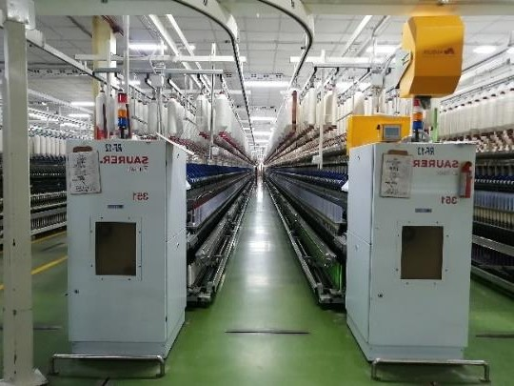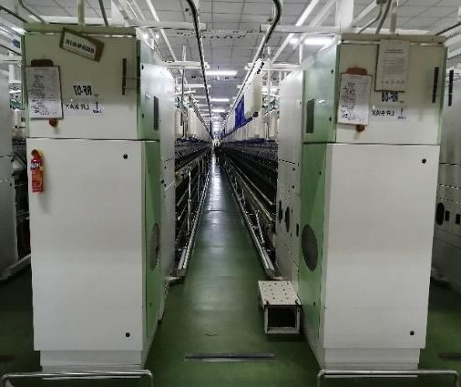

**Figure 3. 11: Ring Frame**

**Technical Parameters of Ring frame is given below:**

**Table 3. 5: Technical parameters of the ring frame:**

|  |  |
| --- | --- |
| **Technical Parameters** | **Value** |
| Number of machines | 14 (Zinser) |
| Number of Spindles per Machine | 1200 (Zinser) |
| Spindle Speed | 16500 RPM |
| Bottom Roller Gauge | Front- 42.5 mm (Zinser)  Back- 70 mm (Zinser) |
| Bottom Roller Diameter | Front- 27 mm  Middle- 27 mm  Back- 27 mm |
| Spindle Gauge | 70 mm |
| Break Draft | 1.12 (Zinser) |
| Ring Bobbin Diameter | Top- 20 mm  Bottom- 25 mm |
| Spacer type and Size for Zinser | White- 3 mm  Yellow- 3.25 mm  Black- 3.5 mm  Ash- 3.75 mm  Red- 4 mm |
| Traveller Clearer Gauge | 1.8 mm |
| Weighing System | Pneumatic |
| Ring Cup | 40-42 mm |
| Shore Hardness | Front- 65°A  Back- 75°A |
| Doffing | Automatic |
| Traveller Manufacturer | Laxmi (INDIA)  Bracker (Switzerland) |
| Count | 30 Ne |
| Production | 250-300 kg/shift (Zinser) |

## : HVI:

This is used mainly for assisting in bale management. This equipment contains three modules.

* + - * Micronaire
      * Color and trash
      * Length and strength.

## Machine Specifications:

|  |  |
| --- | --- |
| Machine Name | HVI |
| Model | HVI 1000 |
| Manufacturer Company | USTER |
| Country of origin | Switzerland |
| Manufacturer Year | 2015 |

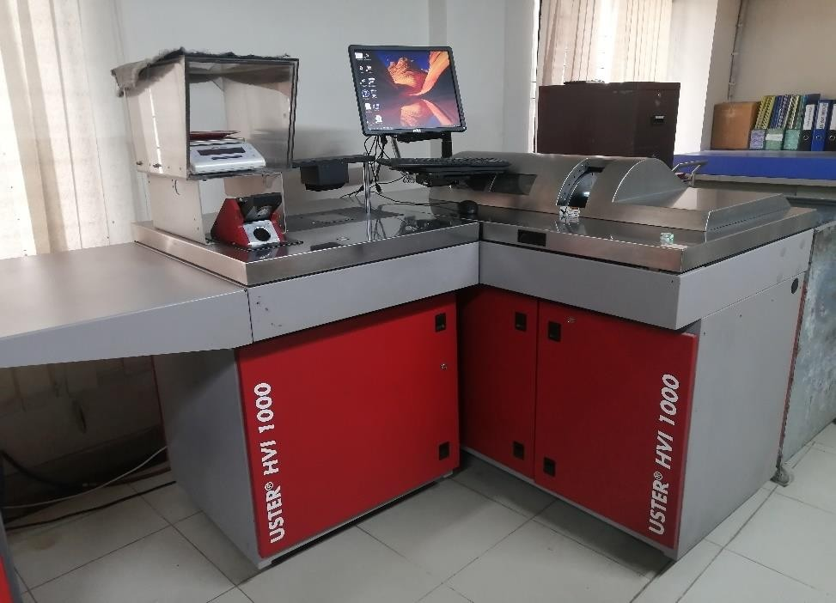

**Figure 3. 12: HVI 1000**

**Function:** To measure MIC value, Maturity, Upper Half Mean Length (UHML), Spinning Consistency Index (SCI), Length, Uniformity, Strength, Short Fiber Index, Elongation, Moisture, Reflectance (Rd), Yellowness(+b), Color grade, Trash Content, Trash Area, Trash Grade.

## : USTER AFIS PRO-2:

This equipment is widely used for neps measurement.

This equipment has three modules.

* + - * NC Module (Nep classification)
      * L & M Module (Length and Maturity)
      * Trash Module

## Machine Specifications:

|  |  |
| --- | --- |
| Machine Name | AFIS |
| Model | AFIS PRO-2 |
| Manufacturer Company | Zellweger USTER |
| Country of origin | Switzerland |
| Manufacturer Year | 2015 |

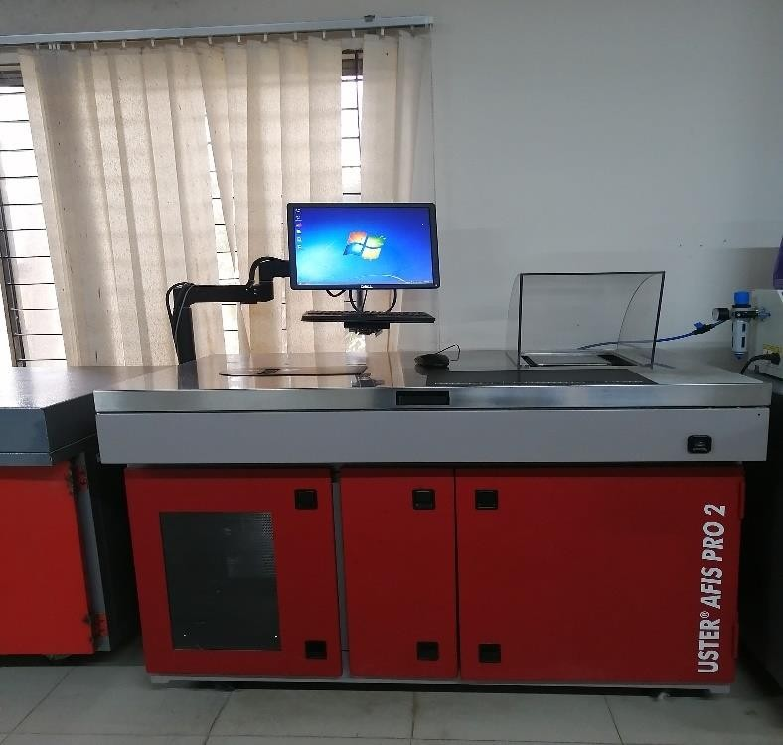

**Figure 3. 13: USTER AFIS PRO-2**

**Function:** To test fibers Nep Content, Strength, Trash, Maturity ratio, etc.

## : Uster tester 5:

USTER evenness tester has two principles. These are capacitive principle and optical principle.

## Machine Specifications:

|  |  |
| --- | --- |
| Machine Name | USTER TESTER |
| Model | UT-5 |
| Manufacturer Company | Zellweger USTER |
| Country of origin | Switzerland |
| Manufacturer Year | 2015 |

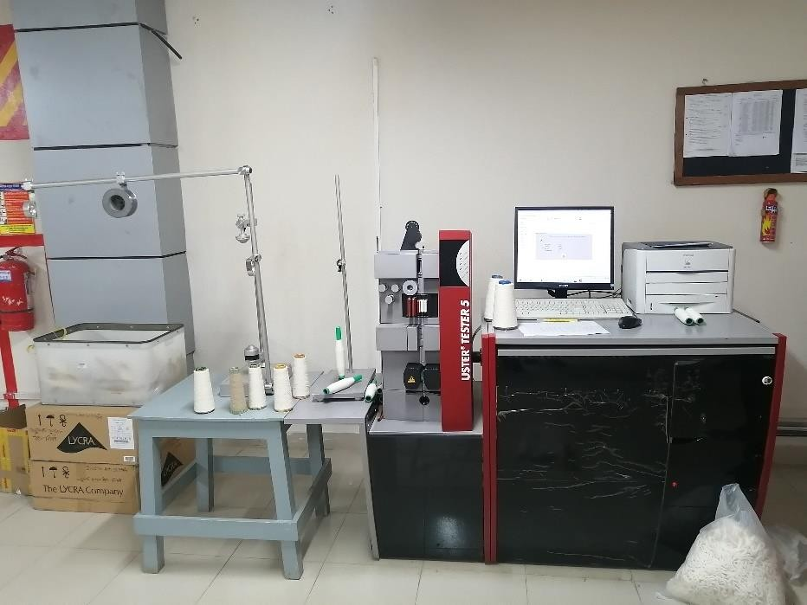

**Figure 3. 14: USTER TESTER-5**

**Function:** It measures the thickness variations, neps, and CV%

## Warp Reel:

A wrap reel or skein winder is a device for measuring yarn and making it into hanks of standard size. The reel is of a standard size and its revolutions are counted as the yarn is wrapped around it. A skein of cotton would be 80 turns on the reel making 120 yards that means one lea.

## Machine Specifications:

|  |  |
| --- | --- |
| Machine Name | Wrap reel |
| Model | Auto warp XT |
| Manufacturer Company | MAG |
| Country of origin | India |
| Manufacturer Year | 2015 |

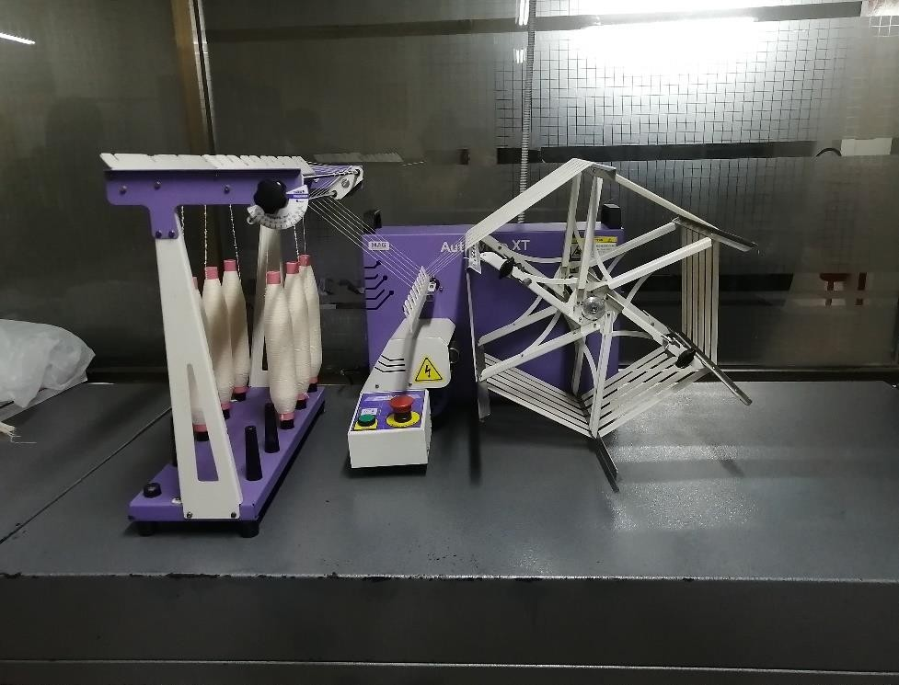

**Figure 3. 15: Wrap Reel**

**Function**: To make the lea of yarn by wrapping yarn around its edges.

## : Lea Strength Tester:

A lea strength tester measures the strength of one lea yarn. One lea means 120 yards. Strength is a measure of the steady force necessary to break a material and is measured in pounds. The machine works at a constant rate of extension.

## Machine Specifications:

|  |  |
| --- | --- |
| Machine Name | Lea Strength Tester |
| Model | Mesdan Lab |
| Manufacturer Company | Mesdan |
| Country of origin | Italy |
| Manufacturer Year | 2015 |

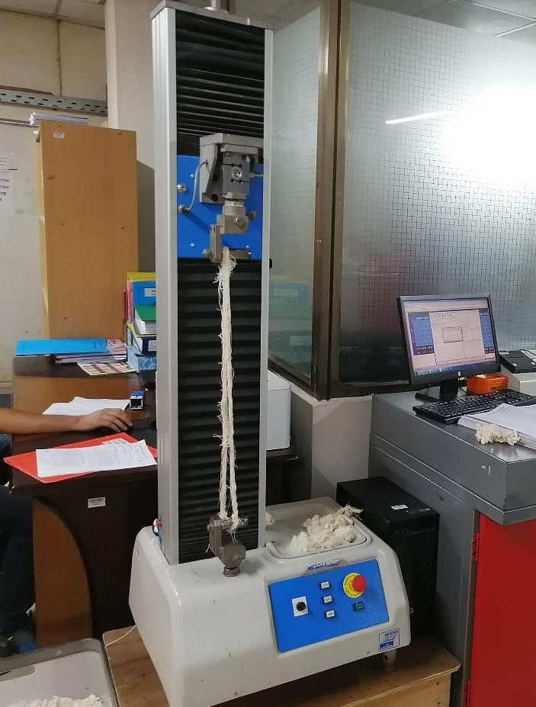

**Figure 3. 16: Lea Strength Tester**

**Function:** To measure the lea strength of yarn

## : Wrap Block:

It is very important to maintain count variation of yarn so that accurate hank of sliver and roving is the same important. By this machine, we checked the hank as per our schedule and take proper steps if required.

## Machine Specifications:

|  |  |
| --- | --- |
| Machine Name | Wrap Block |
| Manufacturer Company | MAG |
| Country of origin | India |
| Manufacturer Year | 2015 |

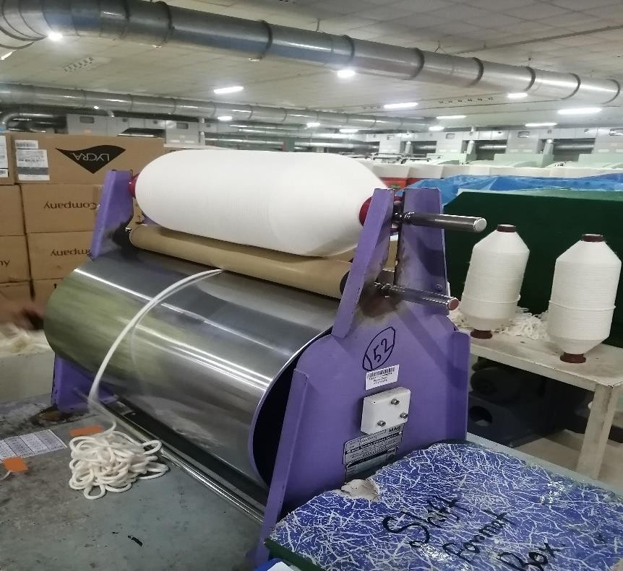

**Figure 3. 17: Wrap Block**

**Figure 3.18. Wrap Block**

**Function:** To measure sliver and roving length for determining the sliver and roving hank.

3.6.9. Moisture Meter

Moisture meter is very important to measure the moisture content in both raw cotton and Finished yarn cones. It helps to prevent process losses up to a minimum level. QAD checks it at every consignment of raw cotton & finished yarn regularly.

**Machine Specification :**

|  |  |
| --- | --- |
| Machine Name | Moisture Meter |
| Model | MESDAN |
| Year of manufacturing | 2015 |
| Country of Origin | Italy |

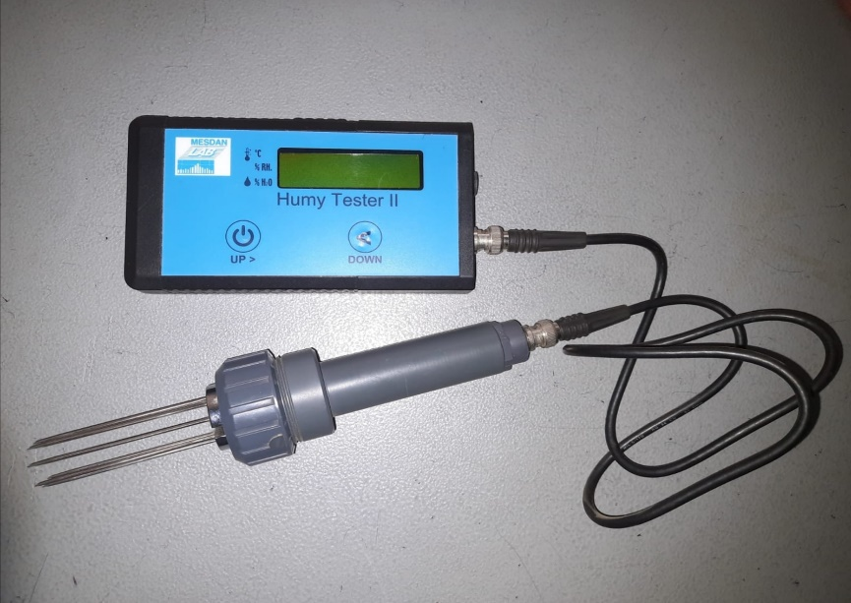

**Figure 3.19:Moisture Meter**

**Functions:** To check the moisture content of raw material and finished goods

**Chapter 04: Results & Discussion**

## 

## Impact of Winding Speed and yarn conditioning on yarn irregularity

**Um % of 20 Ne Carded Yarn**

|  |  |  |
| --- | --- | --- |
| 20 Ne yarn | Um% | |
| Mother yarn | 8.95 | |
| Winding speed(m/min) | Before heat set | After heat set |
| 1300 | 9.78 | 10.11 |
| 1400 | 9.91 | 10.19 |
| 1500 | 9.96 | 10.26 |
| 1600 | 10.05 | 10.40 |

## Impact of winding speed and yarn conditioning on yarn irregularity

## Um % of 30Ne carded yarn

|  |  |  |
| --- | --- | --- |
| 30 Ne yarn | Um% | |
| Mother yarn | 11.59 | |
| Winding speed(m/min) | Before heat set | After heat set |
| 1300 | 11.12 | 11.89 |
| 1400 | 11.26 | 12.01 |
| 1500 | 11.35 | 12.82 |
| 1600 | 11.42 | 12.91 |

## Impact of winding speed and yarn conditioning on yarn irregularity

## CVm% of 30Ne and 20 Ne carded yarn

|  |  |  |
| --- | --- | --- |
| 20 Ne yarn | CVm% | |
| Mother yarn | 11.59 | |
| Winding speed(m/min) | Before heat set | After heat set |
| 1300 | 12.42 | 12.64 |
| 1400 | 12.59 | 12.73 |
| 1500 | 12.60 | 12.78 |
| 1600 | 12.73 | 12.92 |

|  |  |  |
| --- | --- | --- |
| 30 Ne yarn | CVm% | |
| Mother yarn | 11.59 | |
| Winding speed(m/min) | Before heat set | After heat set |
| 1300 | 14.11 | 14.98 |
| 1400 | 14.35 | 15.21 |
| 1500 | 14.37 | 15.35 |
| 1600 | 14.47 | 15.46 |

## Impact of winding speed and yarn conditioning on yarn irregularity

## (Thin and Thick) of 30Ne and 20 Ne carded yarn

|  |  |  |  |
| --- | --- | --- | --- |
| **20 ne Yarns** | | **Thin(-50%/km)** | |
| **Mother Yarn** | **1.5** | | |
| **Winding speed (m/min)** | **Before heat set** | | **After heat set** |
| **1300** | **1** | | **1.25** |
| **1400** | **1.5** | | **1.50** |
| **1500** | **1.75** | | **1.90** |
| **1600** | **2.00** | | **2.1** |

|  |  |  |
| --- | --- | --- |
| **Yarns** | **Thick(+50%)** | |
| **Mother yarn** | **48** | |
| **Winding Speed(m/min)** | **Before yarn conditioning** | **After yarn conditioning** |
| **1300** | **36** | **52** |
| **1400** | **46** | **56** |
| **1500** | **47** | **58** |
| **1600** | **51** | **62** |

|  |  |  |
| --- | --- | --- |
| **30 Ne yarns** | **Thin(-50%/km)** | |
| **Mother yarn** | **2** | |
| **Winding speed (m/min)** | **Before heat set** | **After heat set** |
| **1300** | **2** | **3** |
| **1400** | **3** | **4** |
| **1500** | **4** | **5** |
| **1600** | **5** | **5.5** |

|  |  |  |
| --- | --- | --- |
| **30 Ne yarns** | **Thick(+50%/km)** | |
| **Mother yarn** | **148** | |
| **Winding speed (m/min)** | **Before heat set** | **After heat set** |
| **1300** | **109** | **172** |
| **1400** | **111** | **177** |
| **1500** | **113** | **183** |
| **1600** | **114** | **194** |

The above graph shows that the influence on wind speed and yarn Conditioning Um% and CVm% of 20 Ne carded and 30 Ne carded yarn.

It is clearly observed that, Um% and CVm% of 20 Ne KH and 30 Ne KH has been decreased with the decrease of winding speed, in both case of before yarn conditioning and after yarn conditioning.

With the decrease of winding speed, unit length per second of the material passed through the yarn clearer decrease and yarn clearer has more time to correct the faults of the yarn. Which resulted in the decreasing rate of co-efficient of variations of the yarn.

## Impact of winding speed and yarn conditioning on yarn irregularity

## Neps(+200%/Km)

## of 20Ne carded yarn

|  |  |  |
| --- | --- | --- |
| 20 Ne yarn | Neps | |
| Mother yarn | 60.9 | |
| Winding speed(m/min) | Before heat set | After heat set |
| 1300 | 66 | 78 |
| 1400 | 70 | 85 |
| 1500 | 76 | 89 |
| 1600 | 79 | 110 |

## Impact of winding speed and yarn conditioning on yarn irregularity

## Neps(+200%/Km)

## of 30Ne carded yarn

|  |  |  |
| --- | --- | --- |
| 30 Ne yarn | Neps | |
| Mother yarn | 346 | |
| Winding speed(m/min) | Before heat set | After heat set |
| 1300 | 338 | 373 |
| 1400 | 341 | 385 |
| 1500 | 353 | 390 |
| 1600 | 384 | 404 |

The above graph shows the Neps (+200%/km) of 20 Ne KH and 30 Ne KH

produced with different winding speeds.

It is plainly observed that, Neps (+200%/km) of 20 Ne KH and 30 Ne KH has been increased with the increase of winding speed, in both case of before yarn conditioning and after yarn conditioning.

The increase in neps can be attributed to the conversion of hairs into neps due to abrasion of yarn against the guiding elements of winding machine.

## Impact of winding speed and yarn conditioning on yarn irregularity

## CSP

## of 20Ne carded yarn

|  |  |  |
| --- | --- | --- |
| 20 Ne yarn | CSP | |
| Mother yarn | 2890.47 | |
| Winding speed(m/min) | Before heat set | After heat set |
| 1600 | 2870.4 | 2866.72 |
| 1500 | 2982.8 | 2948.97 |
| 1400 | 2987.4 | 2995.20 |
| 1300 | 3017.75 | 3000.56 |

## Impact of winding speed and yarn conditioning on yarn irregularity

## CSP

## of 30Ne carded yarn

|  |  |  |
| --- | --- | --- |
| 30 Ne yarn | CSP | |
| Mother yarn | 2950 | |
| Winding speed(m/min) | Before heat set | After heat set |
| 1300 | 2998. 12 | 3018.36 |
| 1400 | 2995.40 | 2982.82 |
| 1500 | 2948.97 | 2878.23 |
| 1600 | 2905.72 | 2870.79 |

The above graph illustrates the relationship between the CSP value of 20 Ne KH & 30 Ne KH with different winding speed of autocone.

It is clearly visible from the graph that the CSP value increases gradually with the decrease of winding speed.

The increasing of winding speed increases the imperfection value and unevenness of yarn. It also increases the hairiness of yarn. This is the ultimate issue for worsening the yarn strength. For this, Count Strength Product (CSP) decreases when the winding speed increase.

# 

# Chapter 05: Conclusion

## .Limitations

Number of testing sample was small. A large number of sample might

provide more accurate result.

## 5.2.Conclusion

Impact of winding speed and yarn conditioning are observed for two different count 20 Ne carded and 30 Ne carded yarns were selected for the process. Impact of yarn conditioning had also been compared between the Uster report of pre conditioned yarn and post conditioned yarn. Um%, CVm%, thin, thick, neps, CSP increases with the increasing of winding speed. Uster result of post conditioned yarn also show an increase in the value of Um%, CVm%, thin, thick, neps, IPI, CSP compared to the pre conditioned yarn. So, it can be said that if anyone want to increase the quality of yarn from the same type of raw materials, he/she can just do it with the changing of winding speed**.** At last but not least we’d like to recommend for further elaborative study to get more analysis on this topic.

Reference:

1. An application of Pareto analysis and cause-andeffect diagram (CED) to examine stoppage losses a textile case from Bangladesh

2. Effect of Repeated Winding on Carded Ring Cotton yarn Properties

3.Aly, Karim. (2008). Theoretical and Experimental Investigation of the Effective

Parameters on Yarn Properties During Winding and Twisting Processes.

10.13140/RG.2.1.2861.9128.

4. Kumar, R. S. (2015). Process Management in Spinning. CRC Press Tylor & Francis Group. Florida, USA

5. Fundamentals of Spun Yarn Technology (2003)

6. The_Rieter_Manual_of_Spinning_vol._4_1924-v2_en_Original__68500

7. Thilagavathi, G. and Karthik, T. (2016). Process control and yarn quality in

spinning. Woodhead Publishing India Pvt. Ltd. New Delhi, India.

8. Patel, S. R. (2003). Some Considerations in Designing Auto levelling System for Conventional winding machine (Textile Machinery).11th National Conference on Machines and Mechanisms. Indian Institute of Technology Delhi. New Delhi, India.

9. Gupta, N. (2019). Analysis on the Defects in Yarn Manufacturing Process & its

Prevention in Textile Industry. International Journal of Engineering Inventions,

Vol. 2, No.7, Page. 45-67.

10.Uyanik, S. (2018). A Research on Determining Optimum Splicing Methods in Terms of Fiber Types and Yarn Count. International Journal of Advanced Manufacturing Technology. Vol. 29, No. 01, Page. 22-25.

11.Omeroglu, G. B. S. (2019). Comparative Study on Carded Cotton Yarn Properties Produced by the Conventional Ring and New Modified Ring Spinning System. FIBRES & TEXTILES in Eastern Europe. Vol. 27, No. 02, PP. 45-51.

**Raw data**

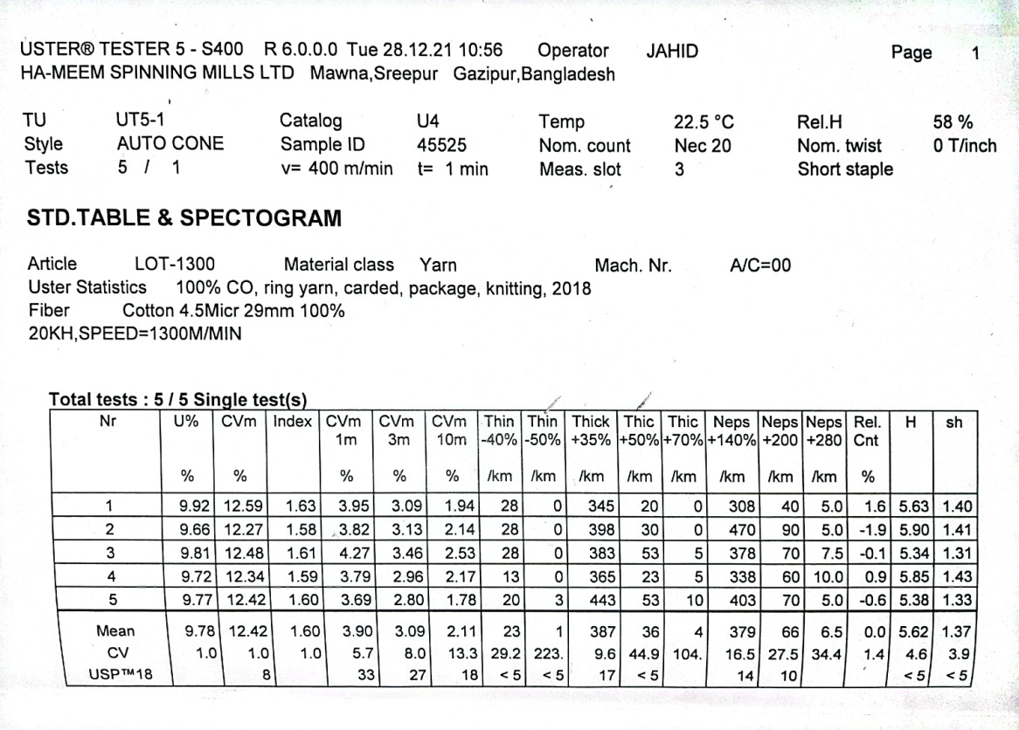

Uster result of 20 Ne yarn at 1300m/min ( before heat set )

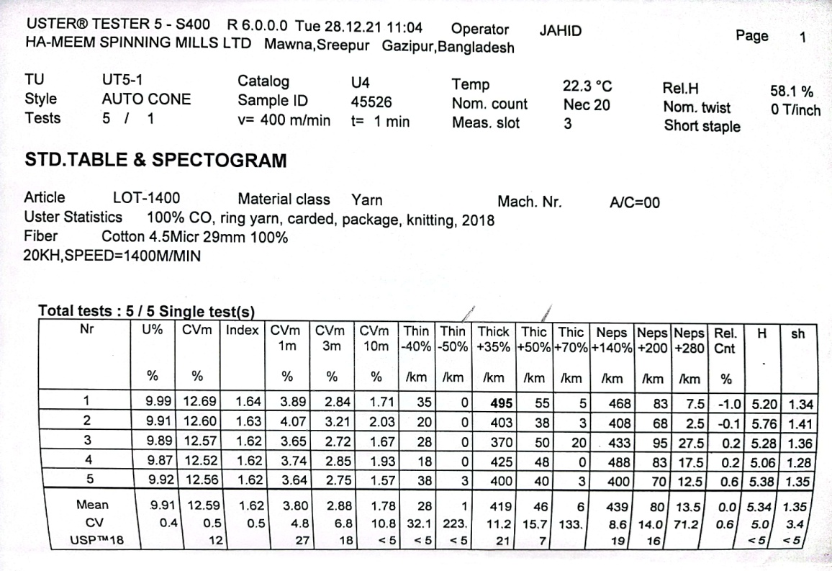

Uster result of 20 Ne yarn at 1400m/min ( before heat set )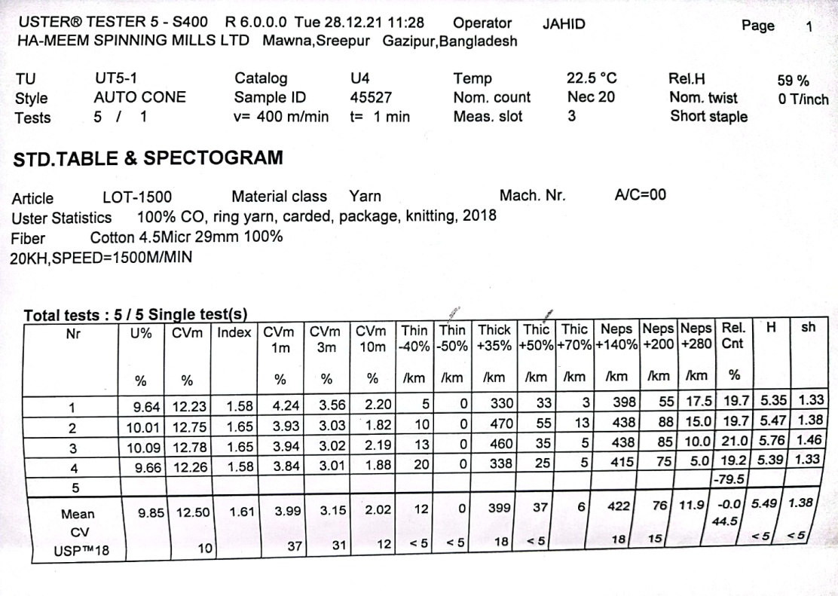

Uster result of 20 Ne yarn at 1500m/min ( before heat set )

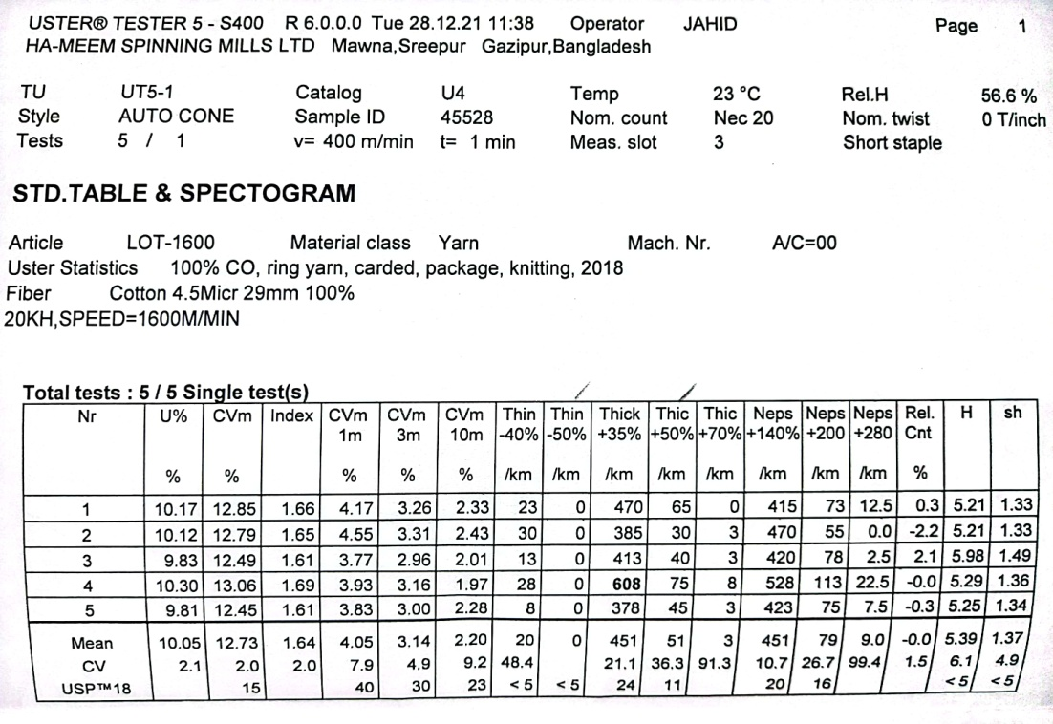

Uster result of 20 Ne yarn at 1600m/min ( before heat set )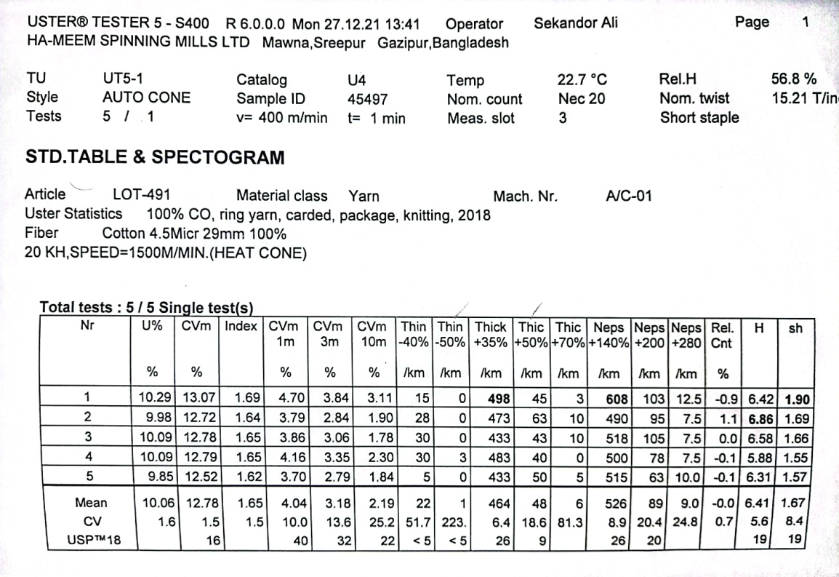

Uster result of 20 Ne yarn at 1500m/min ( after heat set )

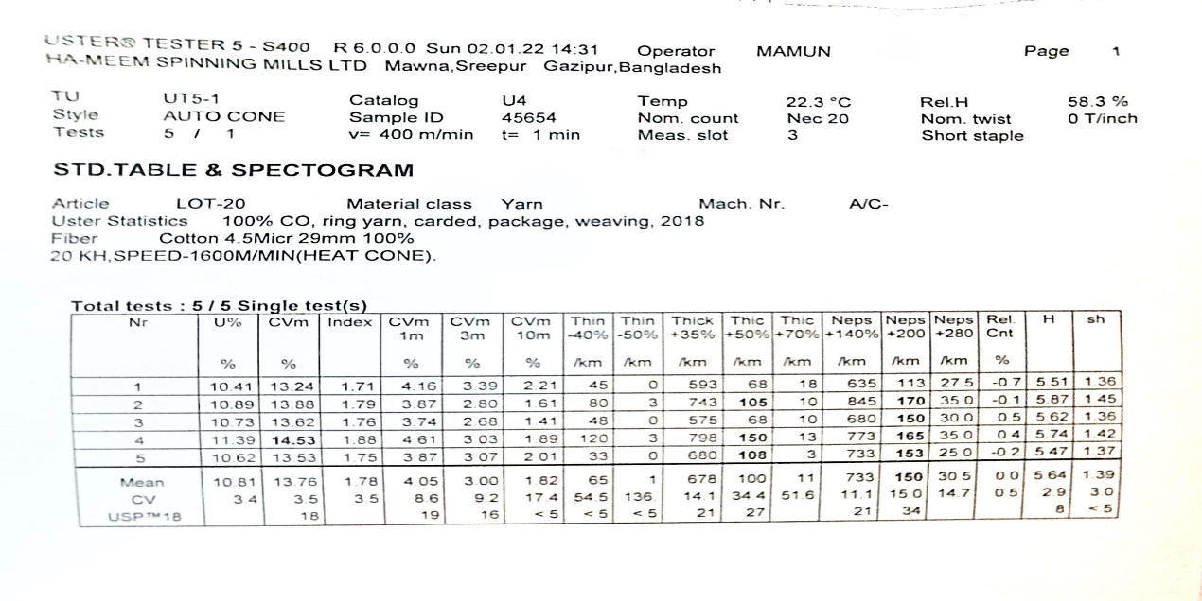

Uster result of 20 Ne yarn at 1600m/min ( after heat set )

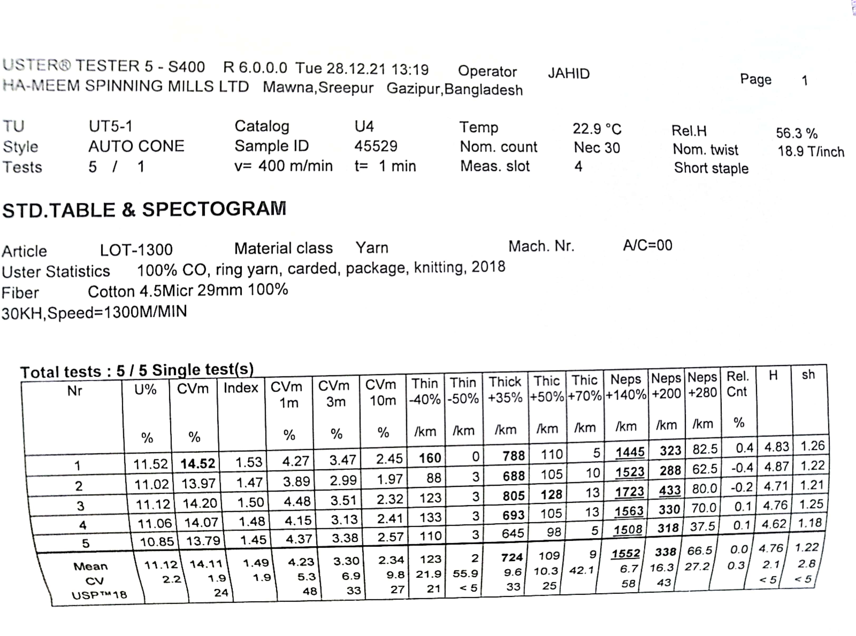

Uster result of 30 Ne yarn at 1300m/min ( before heat set )

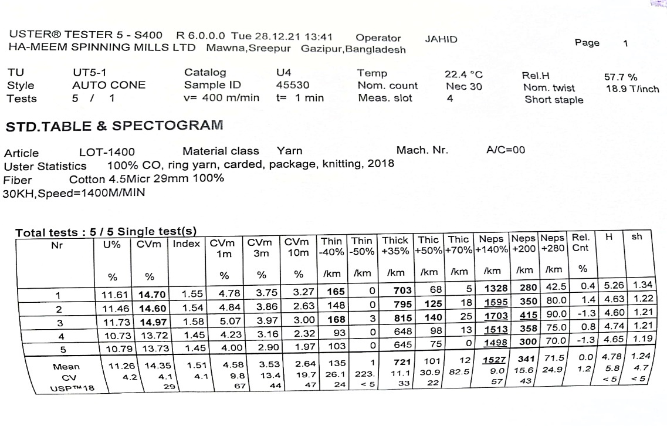

Uster result of 30 Ne yarn at 1400m/min ( before heat set )

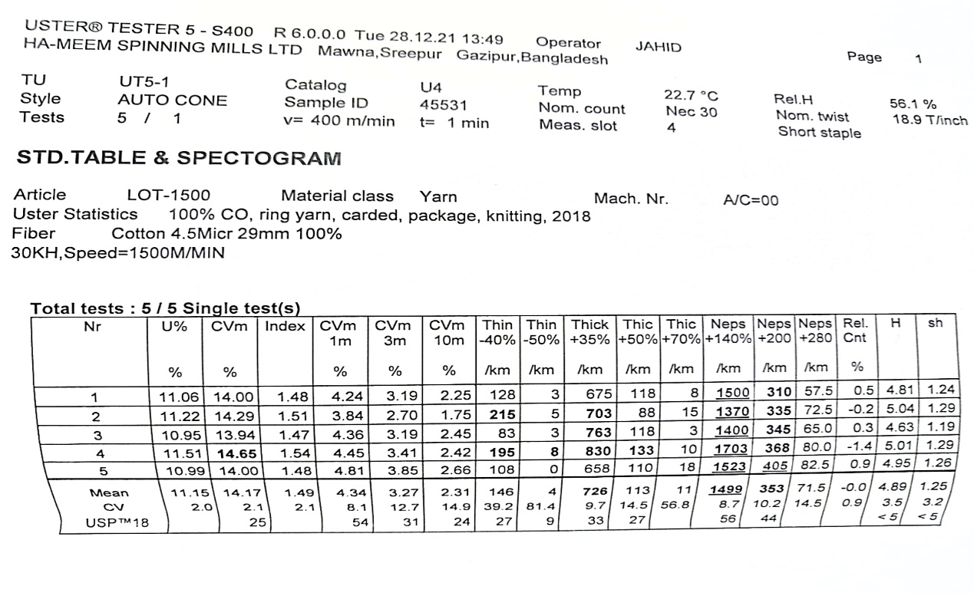 Uster result of 30 Ne yarn at 1500m/min ( before heat set )

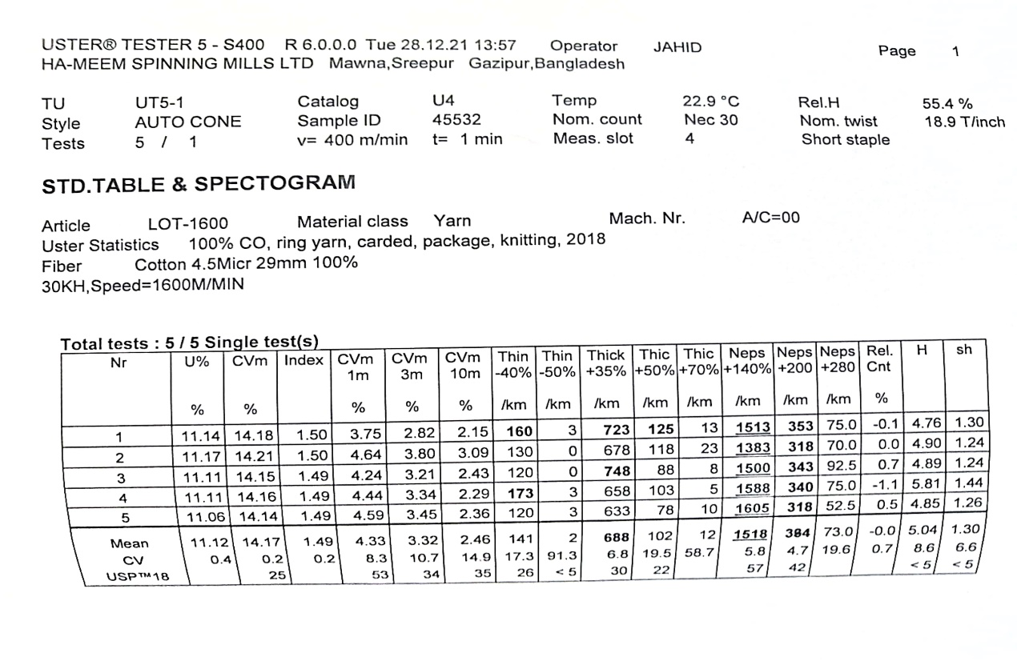

Uster result of 30 Ne yarn at 1600m/min ( before heat set )

Uster result of 30 Ne yarn at 1600m/min ( after heat set )

